Week of September 9, 2002:

Watson Construction completed backfill at the construction yard and north
retaining wall.
(See attached file: Backfill at retaining wall.JPG)

Allan Spear delivered precast for the site walls and West Brick Facade
Wall. Installation of the precast at the facade wall began this weekend
and they worked both Saturday and Sunday.
(See attached file: Precast for West wall.JPG)

Ewing Waterproofing installed waterproofing at the retaining wall north of
the construction yard.
(See attached file: Volclay at retaining wall.JPG)

Lake Glass & Mirror continued installation of the storefront frames and
glass, and also installed the aluminum panels. All exterior aluminum
frames and glass are now installed with the exception of the operable
windows, entrance doors, north curtainwall which is being used for
material distriubution, and glass in front of aluminum panels.
(See attached file: Volclay at retaining wall.JPG)

Kistler McDougall continued installation of the oyster metal wall panels.
Approximately 95% of the exterior panels at the 2nd and 3rd floors are
complete.
(See attached file: Metal panel and large window.JPG)

Mac Drywall continued installation of metal framing and drywall and
insulation at the 2nd and 3rd floor soffit and atrium areas. 3rd floor
dyrwall work at the atrium skylight is installed and is nearing completion
of taping and finishing.
(See attached file: Atrium.JPG)

A. G. Mauro delivered wood doors to the jobsite.
(See attached file: Wood doors.JPG)

Kone delivered the elevator and has begun installation work. PPD's Jack
Thompson has been to the site daily to observe installation of the
elevator.
(See attached file: Elevator Equipment.JPG)(See attached file: Elevator
Rail.JPG)

WW Gay is nearing completion of piping work at the Mechanical Room.
Ductwork installation continued at all floors. Miller Electric continued
relocation of the panels at the 2nd and 3rd floors and began rework to add
2" conduit from multimedia boxes to the projector locations in classroom
areas. Lighting Protection was installed. Brown Automatic began underground
work for the relocated fire line and added PIV. They also continued
installation of sprinkler piping at the 1st floor. Ray's Plumbing has
installed the domestic water meter.
(See attached file: Ground rod for lightning preventer.JPG)(See attached
file: Preventer on roof.JPG)(See attached file: Fire pump feed ditch.JPG)

If you have any questions or comments, please contact me.

Cathy Underhill
Centex Rooney Construction Co., Inc.
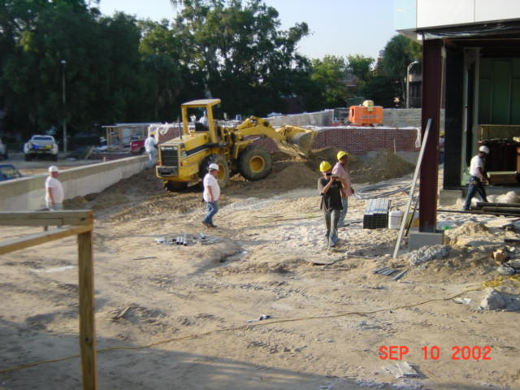
Backfill at retaining wall
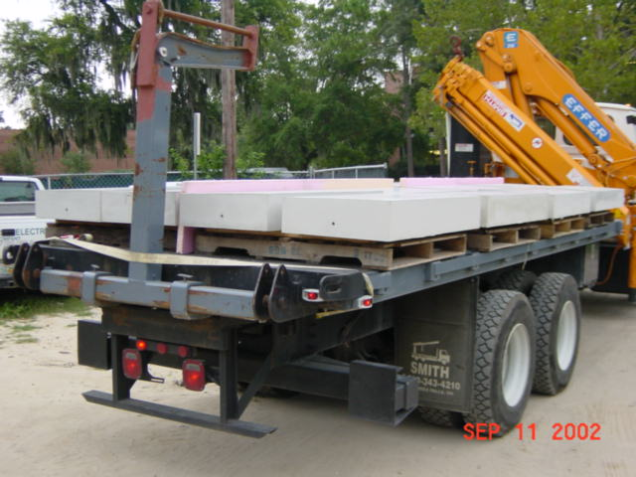
Precast for West wall
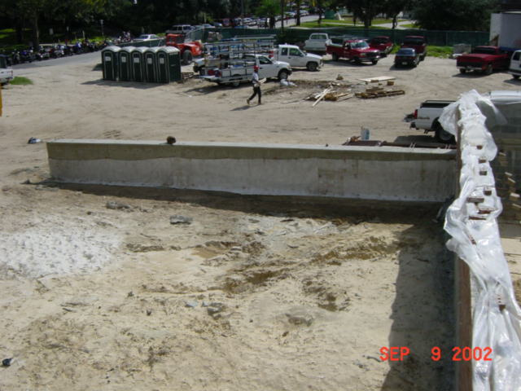
Volclay at retaining wall
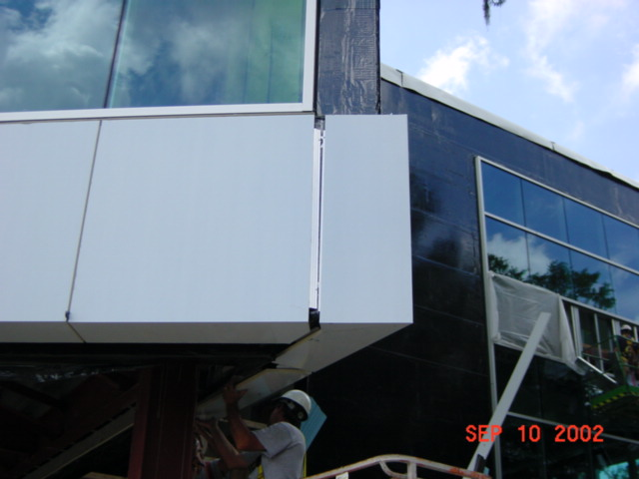
View looking SW
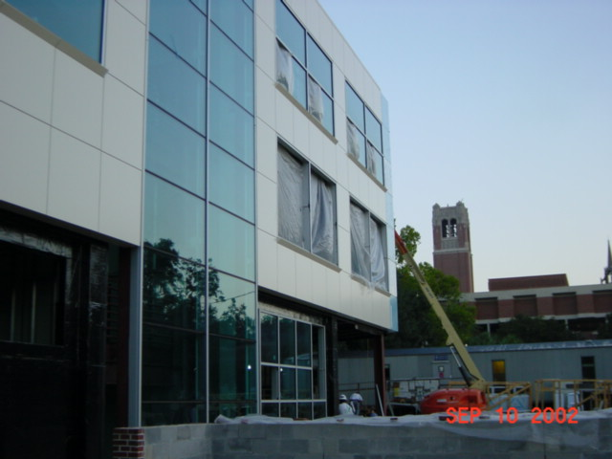
Metal panel and large window
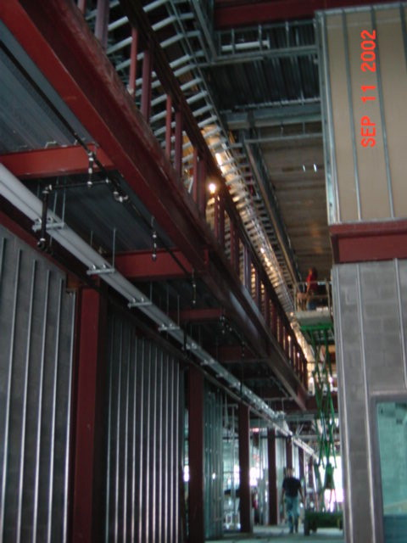
Atrium
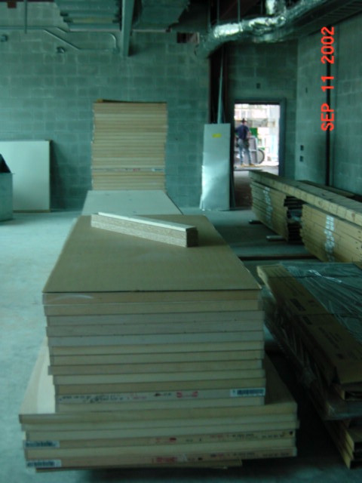
Wood doors
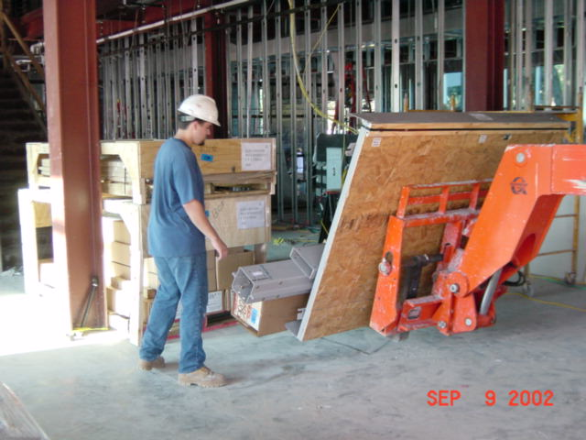
Elevator Equipment
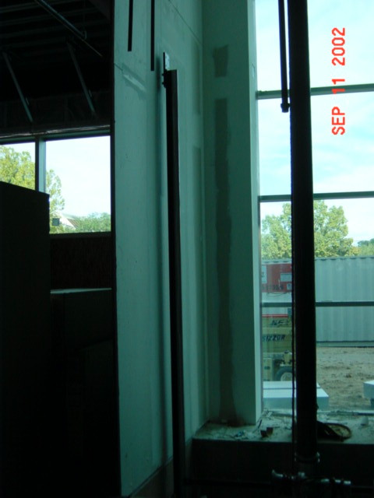
Elevator
Rail
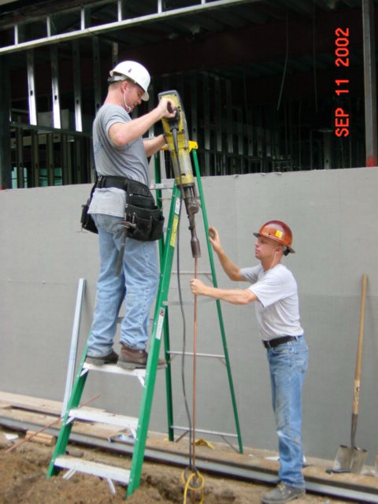
Ground rod for lightning preventer
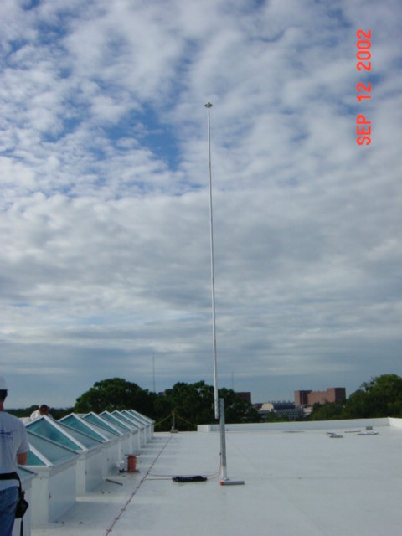
Preventer on roof
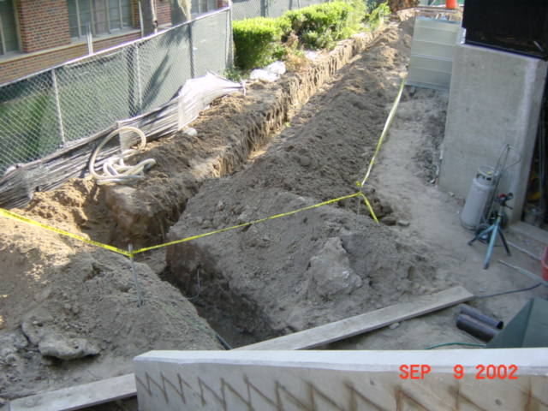
Fire pump feed ditch

