Week of August 12, 2002:

Mac Drywall continued with installation of insulation, drywall and taping
and finishing work at the 2nd floor partitions. The framing inspection for
3rd floor partitions was approved by EH&S, and drywall and insulation work
began at the 3rd floor partitions as well. Framing of soffits at the 2nd
and 3rd floors continued.

Lake Glass continued installation of framing and glass. The 3rd floor west
elevation was completed (except operable windows), as well as framing of
the 2nd floor west elevation. The curtainwall glass & glazing work at the
elevator/stair was completed.
(See attached file: 300lb Glass.JPG)(See attached file: Laminated Glass for
Elevator.JPG)(See attached file: Type 3 curtainwall.JPG)

Kistler McDougall continued with installation of the oyster metal wall
panels at the south elevation.
(See attached file: Metal strips for panels.JPG)(See attached file: First
SE panels.JPG)

Cox Concrete poured the concrete for the atrium stair treads.
(See attached file: Atrium Stair pour.JPG)

MEPF rough-in work continued for WW Gay, Miller Electric, Rays Plumbing and
Brown Automatic. Miller Electric installed the MCC-1 and MCC-1EM panels
this weekend including revisions included in ASI #27. WW Gay continued
installation of ductwork branches at the 3rd floor, mechanical chases and
mechanical room. WW Gay also continued piping work at the 3rd floor and
mechanical room. Brown Automatic continued installing fire protection
piping and heads at the 3rd floor.
(See attached file: 2nd floor hydro test 3.JPG)(See attached file: Fire
alarm box with drilled hole.JPG)(See attached file: Mag Drill at
Column.JPG)(See attached file: Open VAV.JPG)

All Florida Electric set the switch and transformer for the high voltage
terminations at the construction yard.
(See attached file: High Voltage Gear is Set.JPG)(See attached file: High
Voltage Switch.JPG)(See attached file: Setting Enclosure.JPG)

If you have any questions or comments, please contact me.

Cathy Underhill
Centex Rooney Construction Co., Inc.
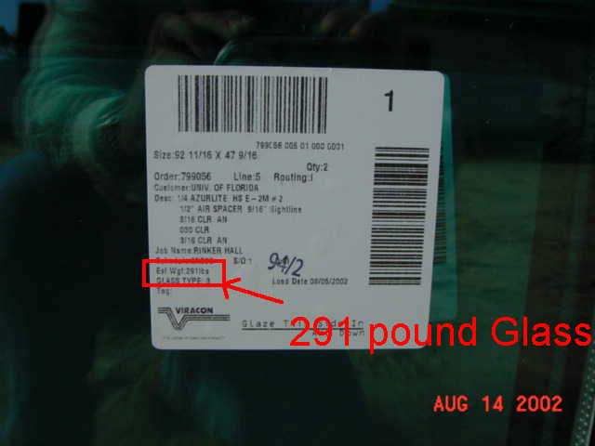
300lb Glass
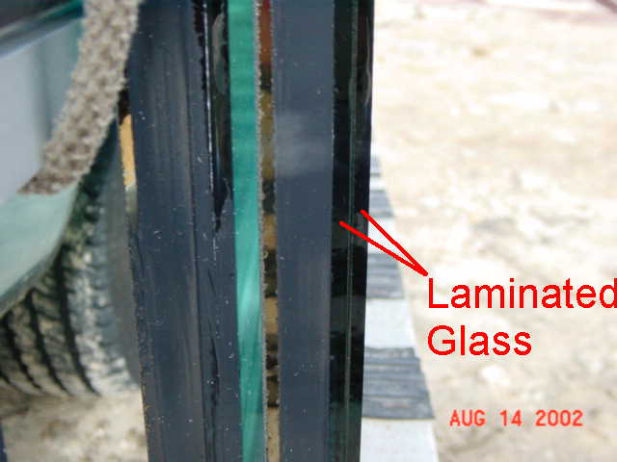
Laminated Glass for
Elevator
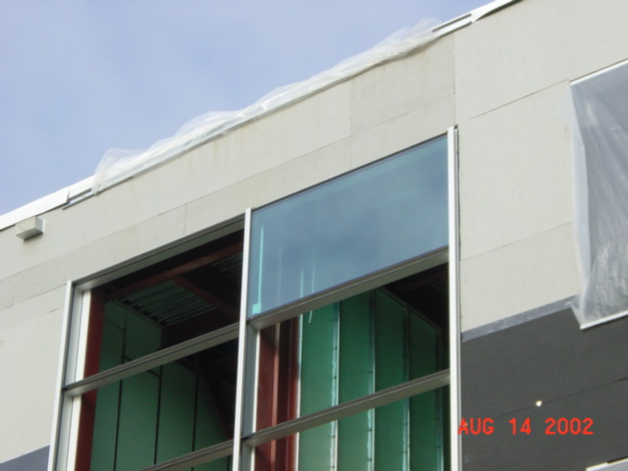
Type 3 curtainwall
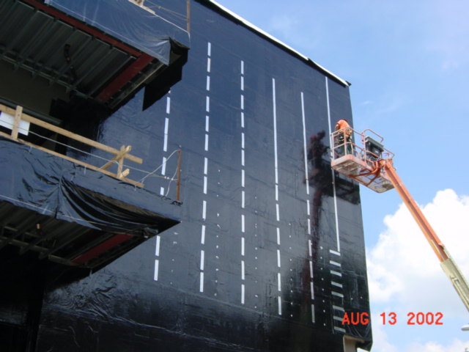
Metal strips for panels
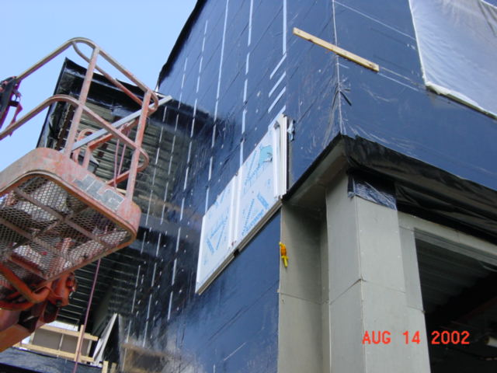
First
SE panels
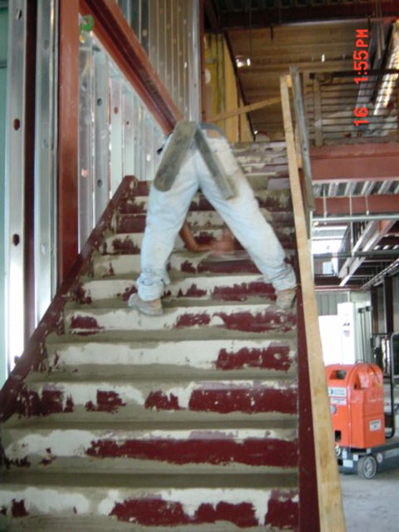
Atrium Stair pour
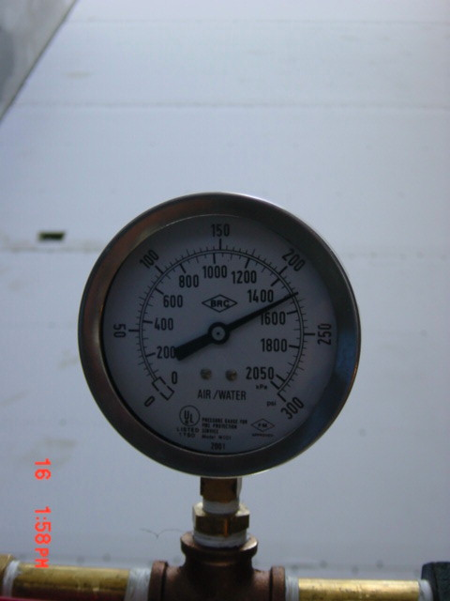
2nd floor hydro test 3
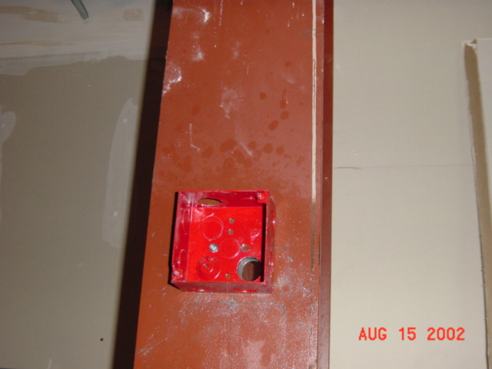
Fire
alarm box with drilled hole
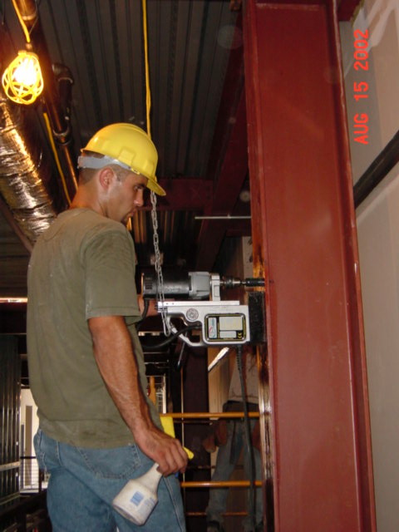
Mag Drill at
Column
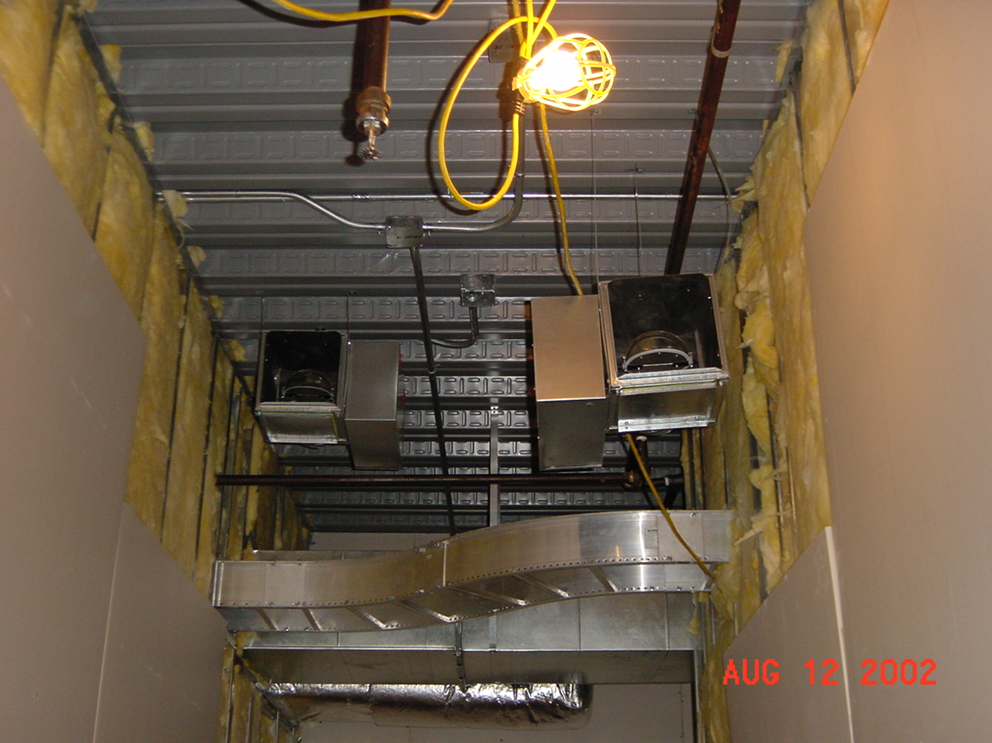
Open VAV
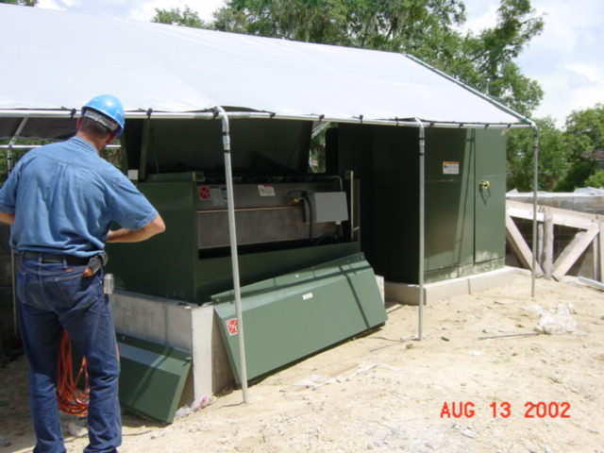
High Voltage Gear is Set
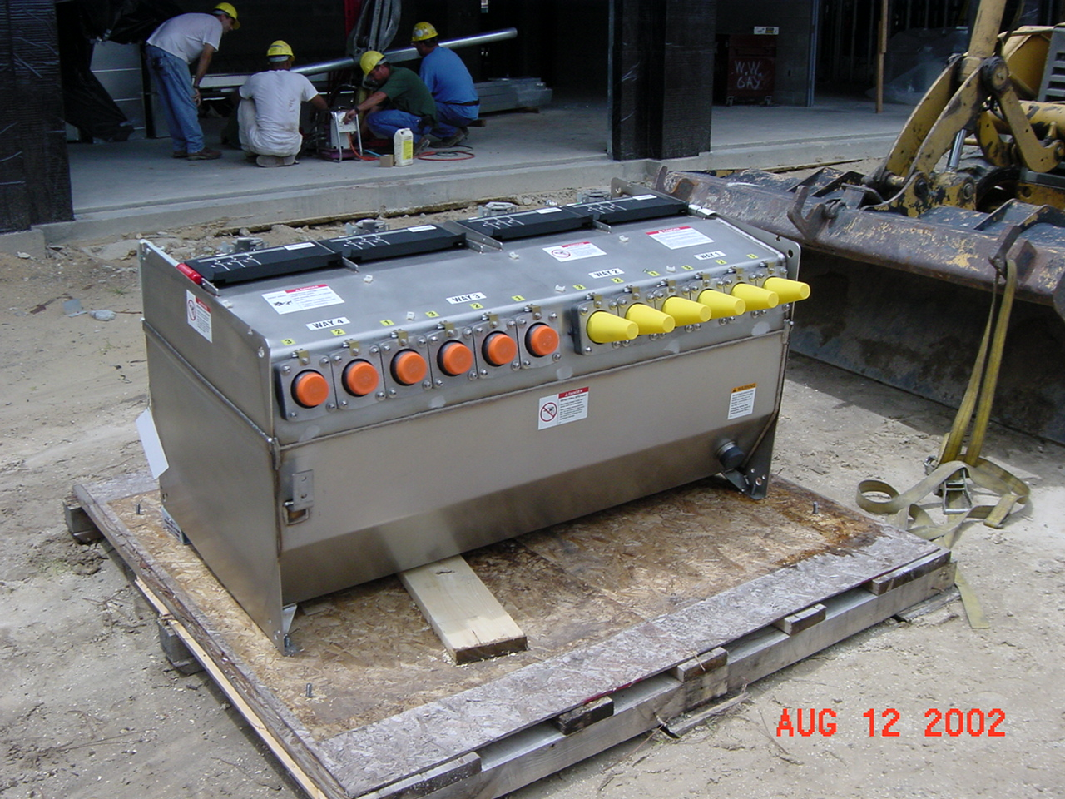
High
Voltage Switch
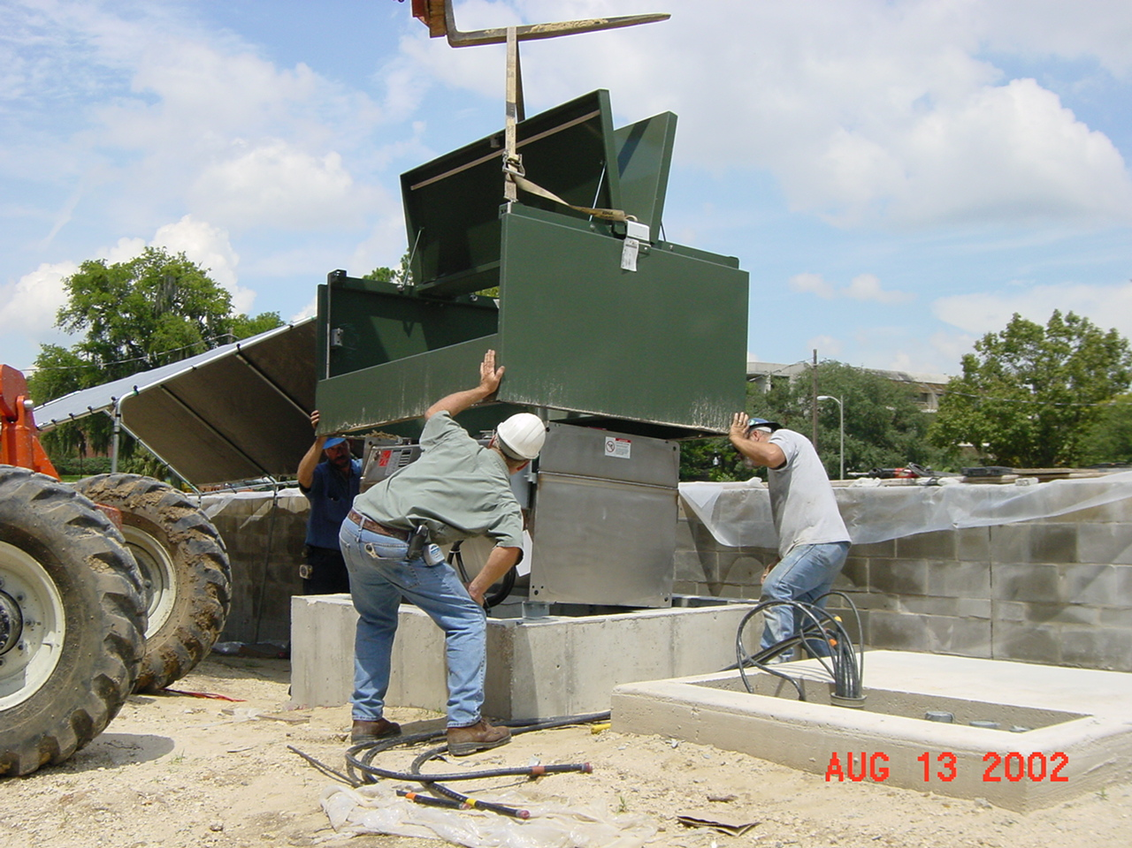
Setting Enclosure

