Week of August 19, 2002:

Mac Drywall continued with metal soffit and ceiling framing at the 2nd and
3rd floors, taping and finishing at 2nd floor, and installation of drywall
and insulation at the 2nd floor soffits and 3rd floor partitions.
(See attached file: Panel Material, 2nd delivery.JPG)

Lake Glass & Mirror continued with installation of the 2nd and 3rd floor
curtainwall framing and glass at punched openings and curtainwall framing
at north elevation.
(See attached file: West.JPG)(See attached file: West side, frames and
barrier.JPG)

Kistler-McDougall continued with installation of the oyster metal wall
panels at the south, east and west elevations. Panels have been delivered
for all work at the south, east and west elevations, including the colonial
red panels at the mechanical room.
(See attached file: East Side, end of work week.JPG)(See attached file:
Panel Material, 2nd delivery.JPG)

WW Gay, Miller Electric and Brown Automatic continued with rough-in work.
Miller Electric pulled cable from the transformer to the electrical room.
Wiring at the 2nd floor continues. WW Gay continued piping at the
mechanical room and 3rd floor above ceiling work. Ductwork continued at
the mechanical room, chases and 3rd floor. Duct silencers and mechanical
room louver were delivered to the jobsite. Brown Automatic continued work
at the 3rd floor and received 1st floor material to begin work here.
Encompass/Ray's Plumbing has demobilized until ready to install plumbing
fixtures.
(See attached file: Demo at 3rd floor elect. room.JPG)(See attached file:
End of Hydronic test, 3rd fl.JPG)(See attached file: Main Electrical
Room.JPG)(See attached file: Start of big cable pulling.JPG)(See attached
file: Layout at heat exchanger.JPG)

All Florida Electric completed installation of the transformer and switch
and connections at Substation #3.

If you have any questions or comments, please contact me.

Cathy Underhill
Centex Rooney Construction Co., Inc.
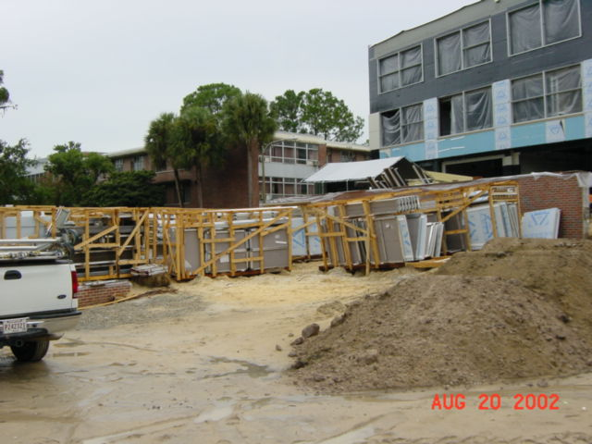
Panel Material, 2nd delivery
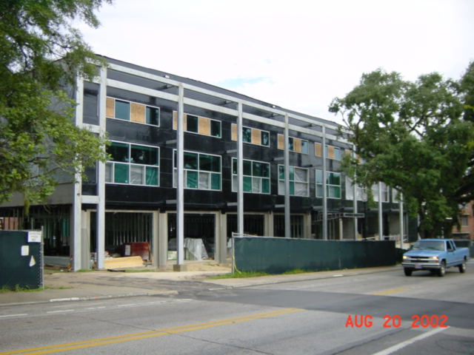
West
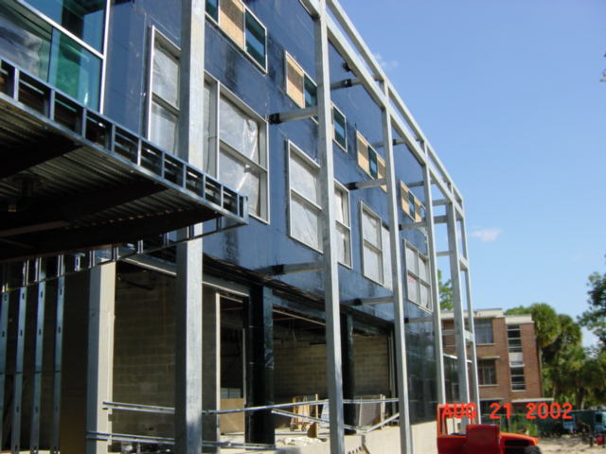
West side, frames and
barrier
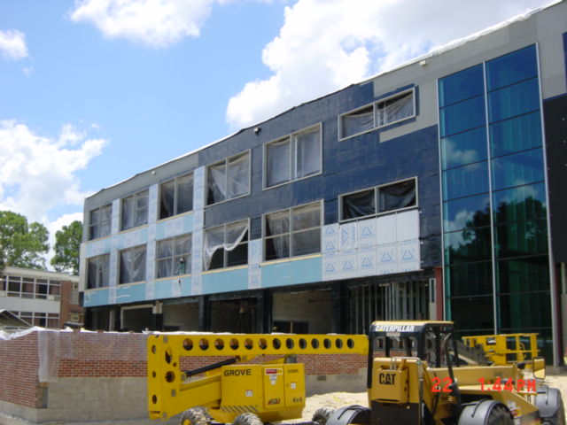
East Side, end of work week
Panel Material, 2nd delivery
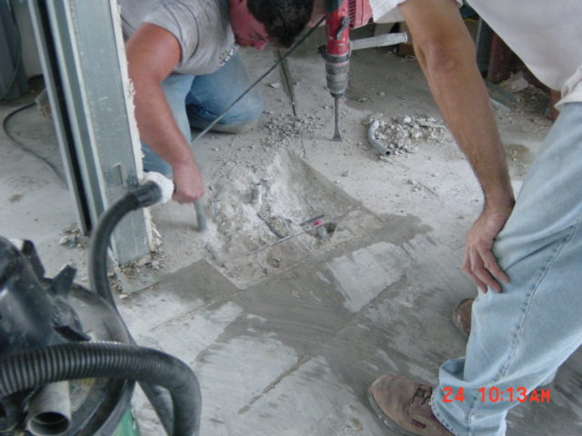
Demo at 3rd floor elect. room
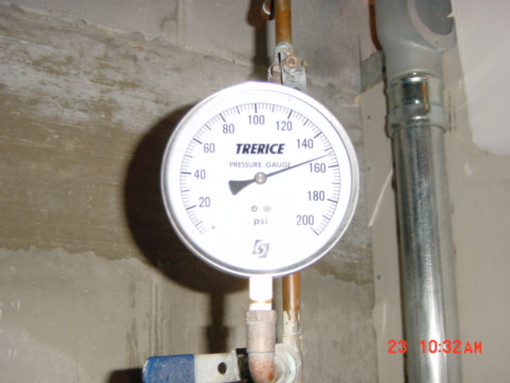
End of Hydronic test, 3rd fl
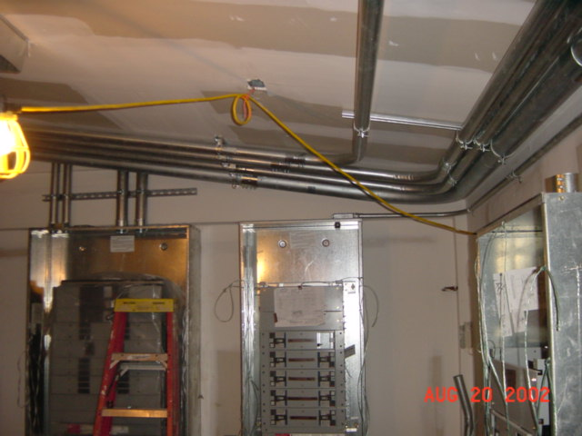
Main Electrical
Room
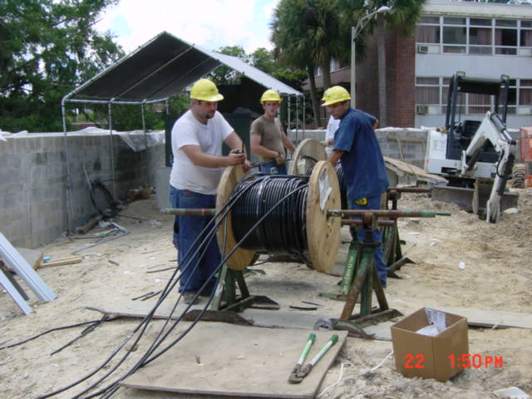
Start of big cable pulling
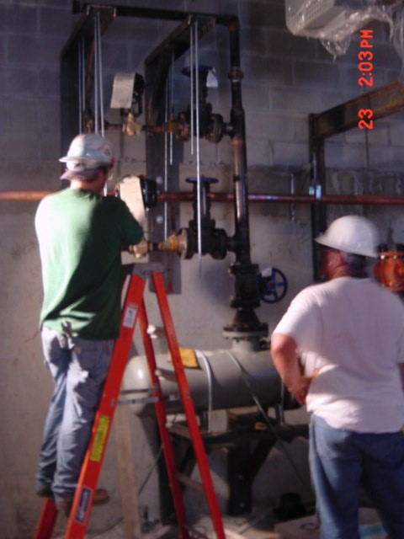
Layout at heat exchanger

