Week of August 5, 2002:

Lake Glass began installation of the window framing and glass at the third
floor, west elevation, and the curtainwall framing at the elevator
shaft/stairs.
(See attached file: First Glass, SW corner.JPG)(See attached file: F Clip,
flashing and window jamb.JPG)(See attached file: Curtainwall type 3.JPG)

Kistler McDougall began installation of the metal wall panels, oyster
color, at the south elevation.
(See attached file: First production day of Panels.JPG)(See attached file:
Alucobond panels 2.JPG)

Mac Drywall continued installation of the Tamko weather barrier and has
completed this installation on the south half of the building (all of south
elevation, and the south half of the west and north elevations). Drywall
installation began at the second floor, and insulation work continued as
well.
(See attached file: Drywall detail at deck.JPG)(See attached file:
Completed insulation at Mech. Room.JPG)(See attached file: Fiberglass at
Mech. Room.JPG)

Allan Spear installed the block and brick at the north elevation of the
construction yard and began block work at the north entry sign.
(See attached file: Sign CMU 2.JPG)

WW Gay, Miller Electric, Rays Plumbing and Brown Automatic continue
rough-in work at the third floor and mechanical room. WW Gay completed
ductwork and EH&S witnessed testing at the third floor. Miller Electric
installed the communications ductbank at the west side of the building.
(See attached file: Telephone duct bank.JPG)(See attached file: Duct test,
3rd floor West side 2.JPG)(See attached file: Duct Test, 3rd floor East
Side.JPG)(See attached file: 3rd Floor Fire Main.JPG)(See attached file:
Completed insulation at Mech. Room.JPG)

If you have any questions, please do not hesitate to call.

Cathy Underhill
Centex Rooney Construction Co., Inc.
.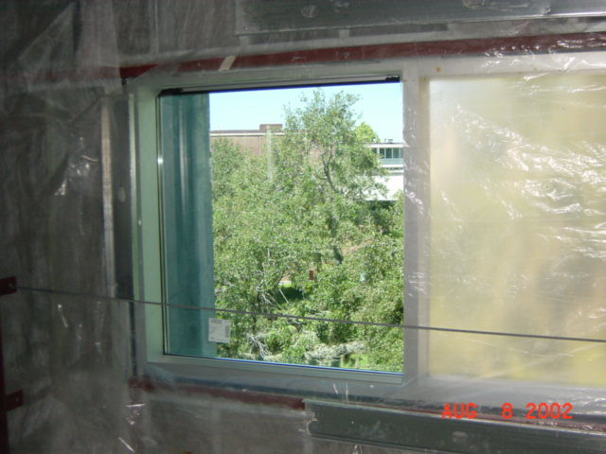
First Glass, SW corner
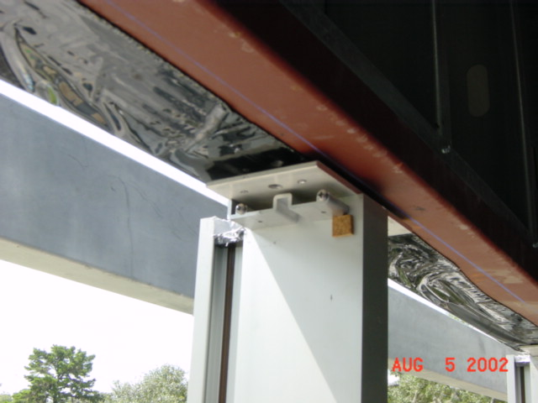
F Clip,
flashing and window jamb
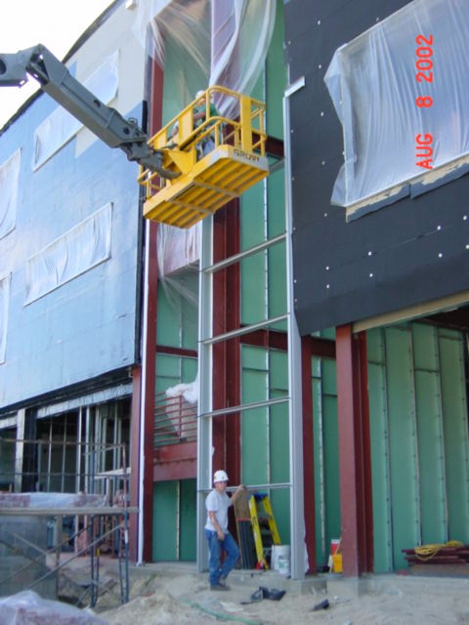
Curtainwall type
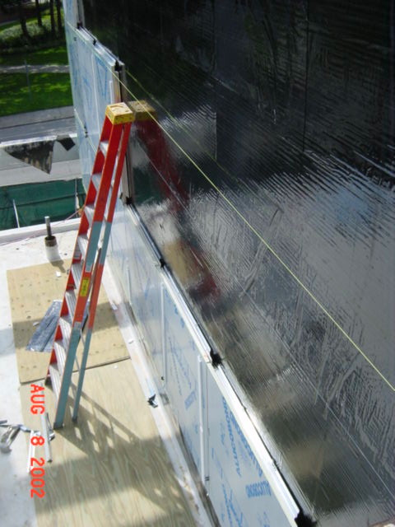
First production day of Panels
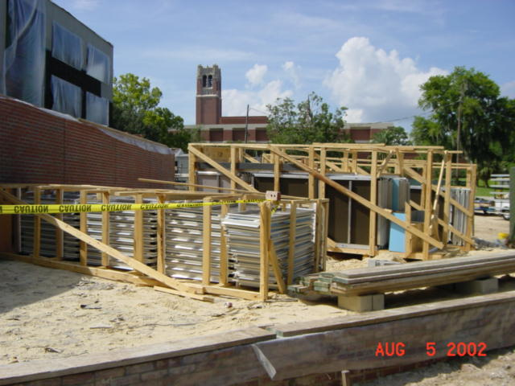
Alucobond panels 2
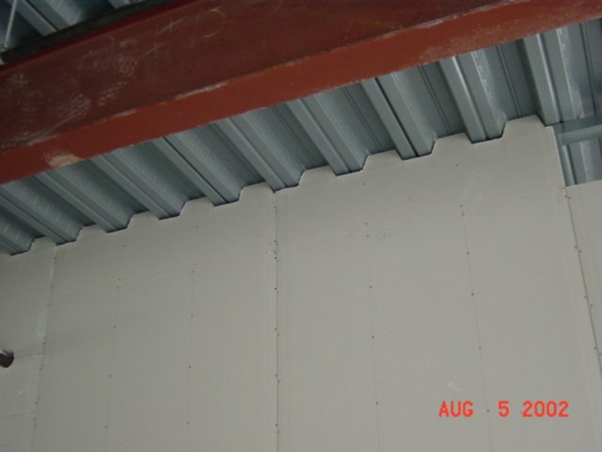
Drywall detail at deck
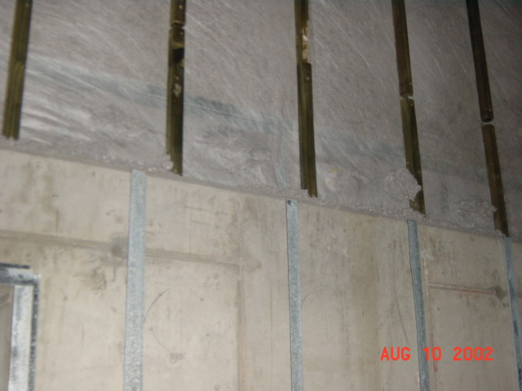
Completed insulation at Mech. Room.
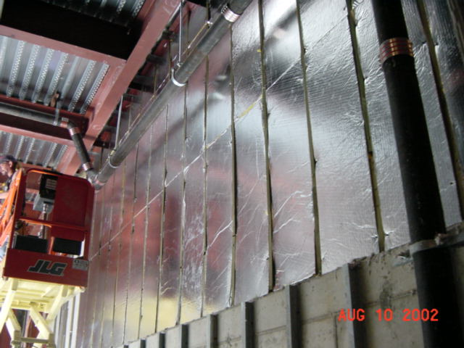
Fiberglass at
Mech. Room
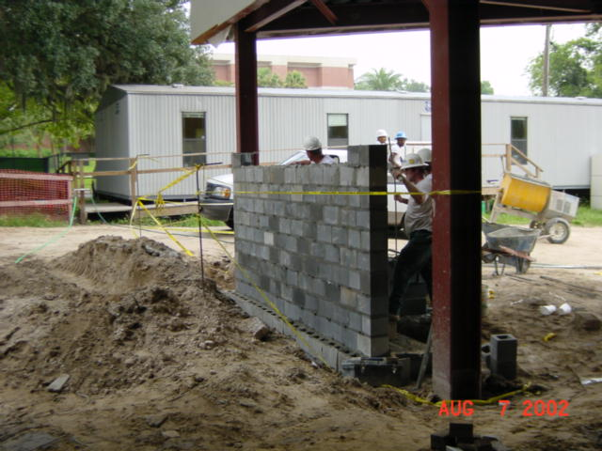
Sign CMU 2
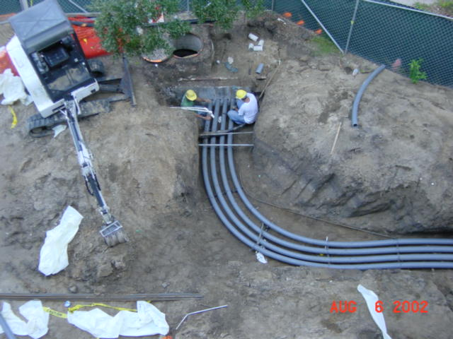
Telephone duct bank
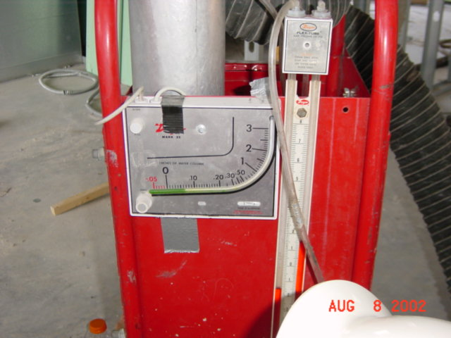
Duct test,
3rd floor West side 2
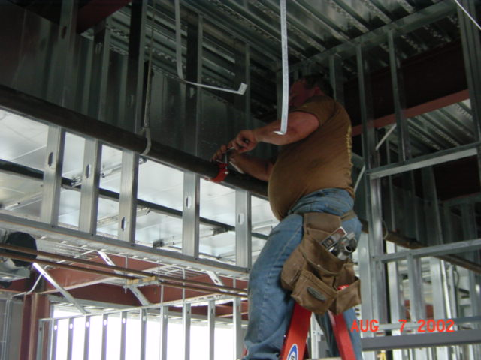
3rd Floor Fire Main
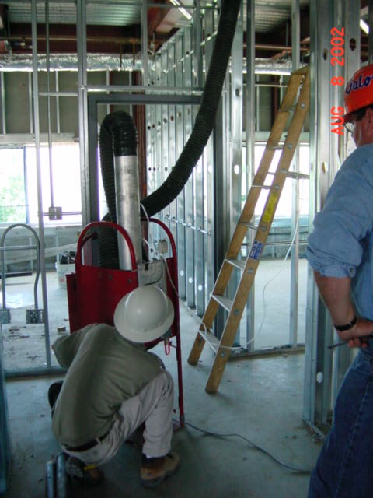
Duct Test, 3rd floor East
Side

