Week of July 22, 2002:

FRAMING: Mac Drywall continued exterior metal sheathing work and received
Temko product for the exterior weather barrier. Interior metal framing
work continued at second and third floor soffits. Interior partition
blocking work continued. Shaftwall construction continued. Cellulose
insulation and firesafing work began at the second and third floors.
(See attached file: Insulation.JPG)(See attached file: Fire Blocking.JPG)

MEPF: WW Gay installed the air handlers and ERV unit in the Mechanical
Room. Ductwork installation continued at the third floor and mechanical
room. The framing inspection for the second floor has been completed by
EH&S and PPD. Miller Electric continued rough-in at the third floor.
Encompass/Ray's Plumbing continued interior piping work at all floors.
Brown Automatic continued fire protection work at the second floor, and
received piping for the third floor.
(See attached file: AHUs, North end.JPG)(See attached file: ERV in
place.JPG)

GLASS: Glass was received for the 2nd and 3rd floor punched openings. Lake
Glass began temporary weather protection of the window opening at the
second and third floors.

(See attached file: Storefront Glass.JPG)(See attached file: East
Elevation.JPG)

STAIRS: Trinity Fabricators installed the Atrium stairs and handrails.
(See attached file: Center Stair Erection.JPG)(See attached file: 2nd Floor
Handrail.JPG)

CONCRETE/BLOCK/BRICK: Alan Spear began installation of the reused Hume
Hall brick at the serpentine site wall in running bond as approved in the
mock-up. Cox Concrete poured the masonry tie beam at the north wall of the
site construction yard wall.
(See attached file: Low Wall.JPG)(See attached file: Beam at North
construction yard.JPG)

If you have any questions or comments, please contact me.

Cathy Underhill
Centex Rooney Construction Co., Inc.

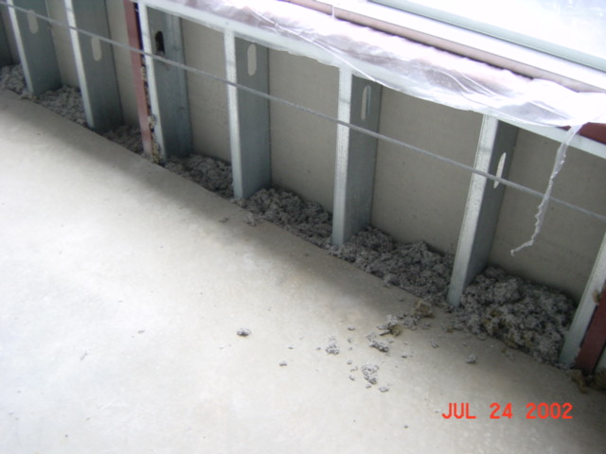
Insulation
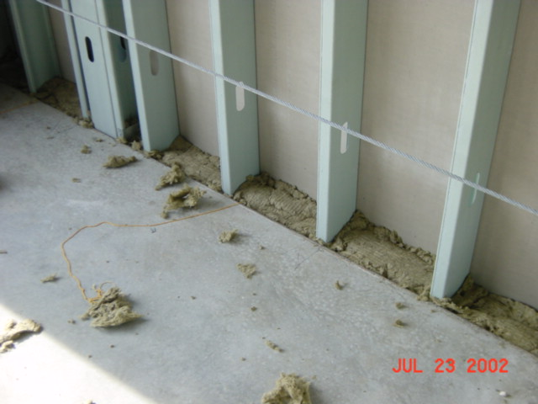
Fire blocking
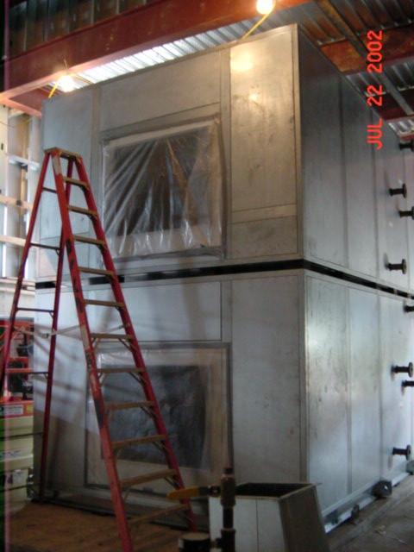
AHU’s, North end
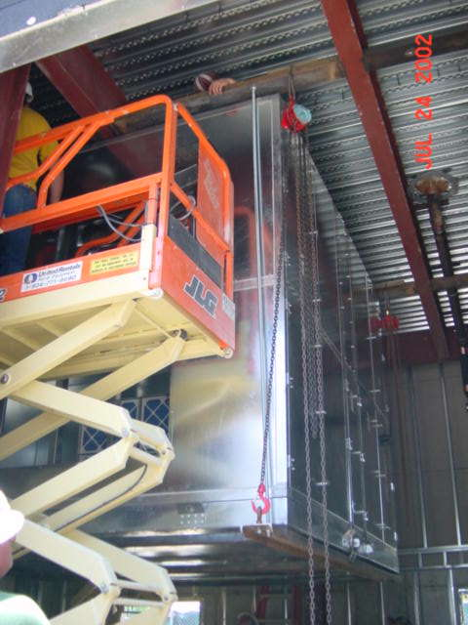
ERV in place
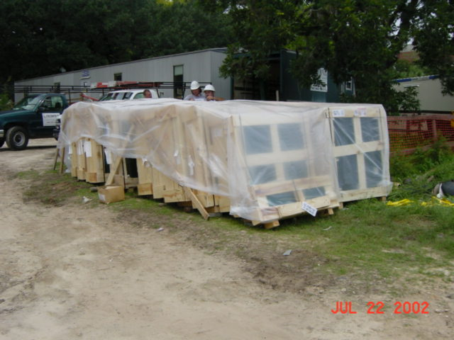
Storefront glass
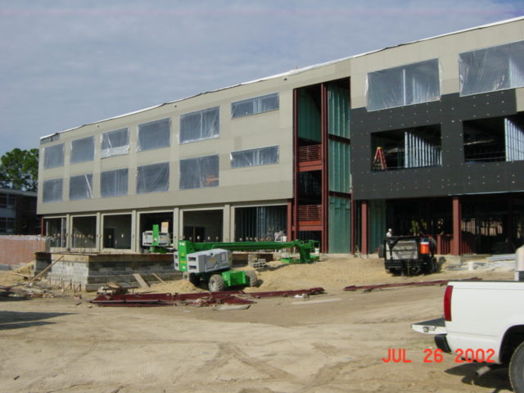
East elevation
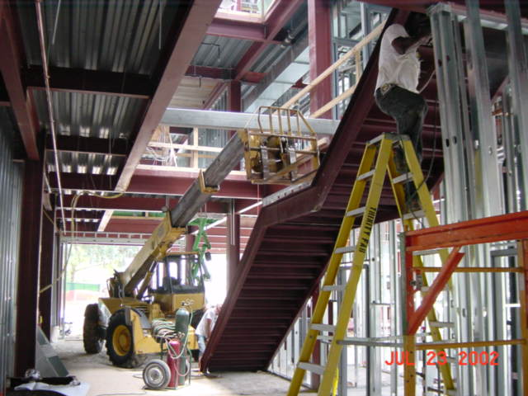
Center stair erection
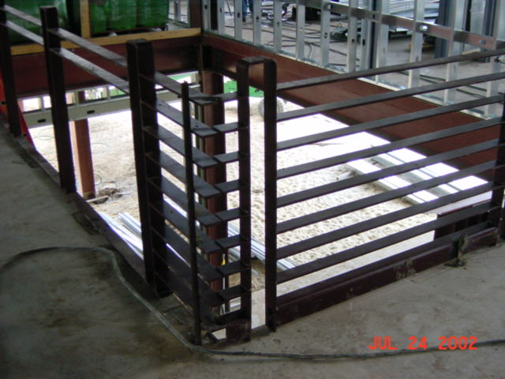
2nd floor handrail
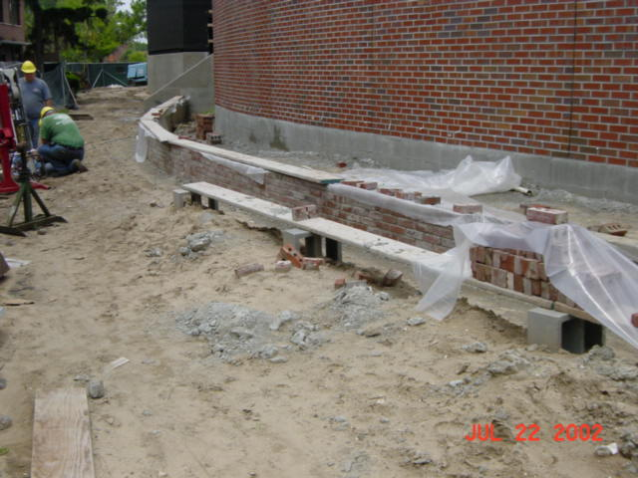
Low wall
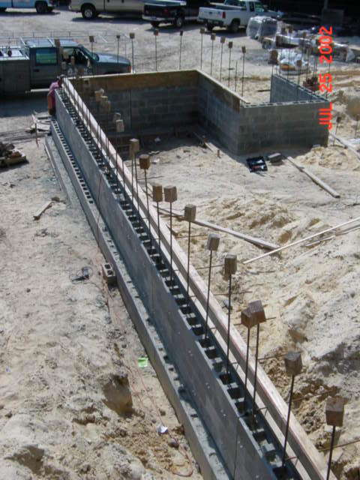
Beam at North Construction yard

