Week of July 29, 2002:

In addition to receiving EH&S framing and MEPF rough-in inspection at the
2nd floor, Centex Rooney also performed a quality control check using a
color-coding system for confirmation of work prior to beginning
installation of insulation/drywall work. Cleaning of the steel columns and
beams was also completed.
(See attached file: Color codes of boxes.JPG)(See attached file: Cleaning
sand from beams.JPG)

Mac Drywall completed exterior sheathing installation and completed the
installation of the Temko weather barrier at the south elevation in
preparation for metal wall panel work to begin. Temporary weather barrier
work was completed for the second and third floors. Framing and drywall
was completed at the Main Electrical Room, and Elevator/Stair shaft wall
installation continued. Third floor skylight framing work began. Fire
safing was installed at the 2nd and 3rd floor perimeters.
(See attached file: 3rd Floor Framing 3.JPG)(See attached file: 3rd Floor
Framing 1.JPG)(See attached file: Insulation at 2nd floor SW corner.JPG)
(See attached file: Vapor Barrier at East wall.JPG)

MEPF trades continued work focusing on rough-in at the third floor.
Ductwork installation continued at the mechanical room. WW Gay installed
the chilled water pumps at the mechanical room.
(See attached file: Chilled water pumps set.JPG)(See attached file: Return
Fan.JPG)

If you have any questions or comments, please contact me.

Cathy Underhill
Centex Rooney Construction Co., Inc.

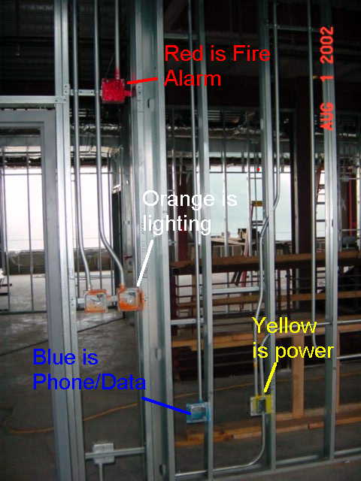
Color codes of boxes
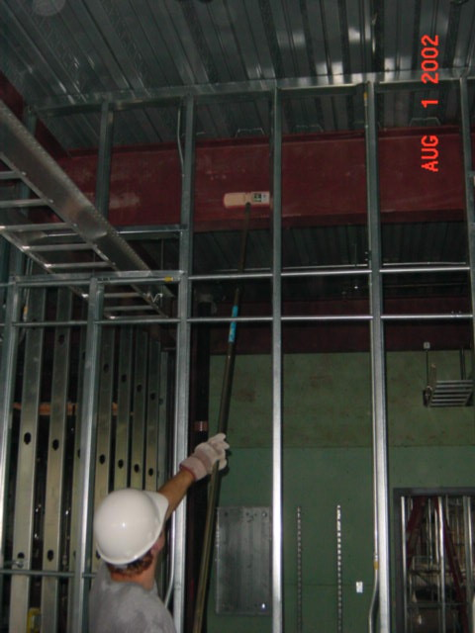
Cleaning
sand from beams
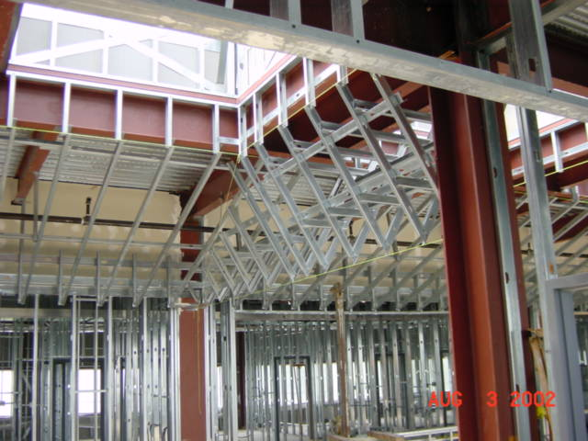
3rd Floor Framing 3
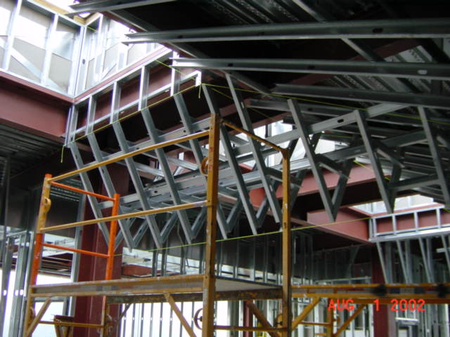
3rd Floor
Framing 1
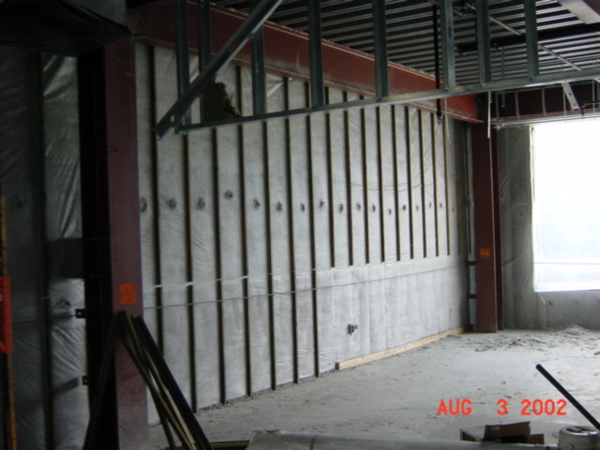
Insulation at 2nd floor SW corner
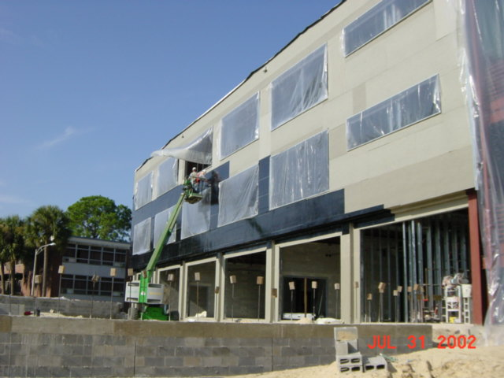
Vapor Barrier at East wall
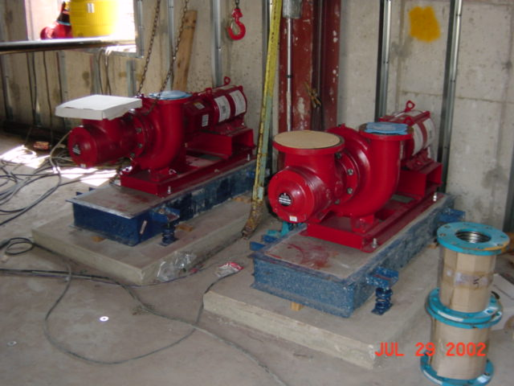
Chilled water pumps set
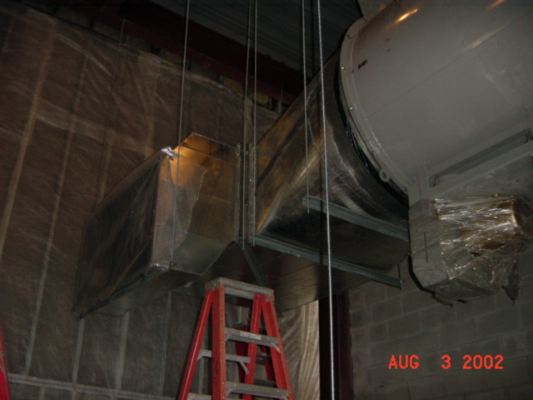
Return
Fan

