Week of October 21, 2002:

Allan Spear continues brick work at the West Facade Wall and has completed all piers except the southernmost pier at the west facade, and the brick at the south stairs.
(See attached file: Brick work upper middle.JPG)(See attached file: Metal studs in middle.JPG)

Teal Tile has begun the tile work in the restrooms at the second floor.
(See attached file: Floor and wall tile.JPG)

Mac Drywall has completed metal studs at the first floor. Drywall installation continues at the first floor. Taping and finishing of the drywall has begun at the first floor. Suncoast continues with installation of the ceiling grid at the third floor. Olympic Painting continues painting the third floor office spaces.

Lake Glass continues installing interior frames.

A.G. Mauro has hung the second floor doors.

Miller Electric has begun installation of the light fixtures at the second floor. WW Gay (T & B Metals) is completing ductwork at the first floor.
(See attached file: First light fixture.JPG)

If you have any questions, please contact me.

Thanks!

Cathy Underhill
Centex Rooney Construction Co., Inc.

(See attached file: Site from E .JPG)

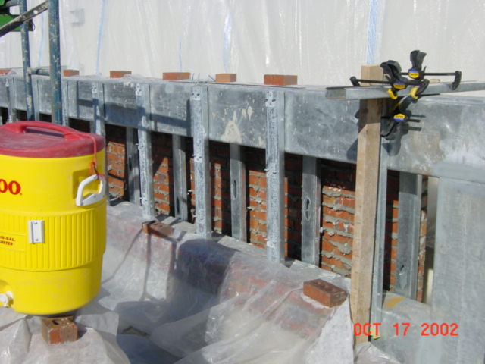
Brick work upper middle
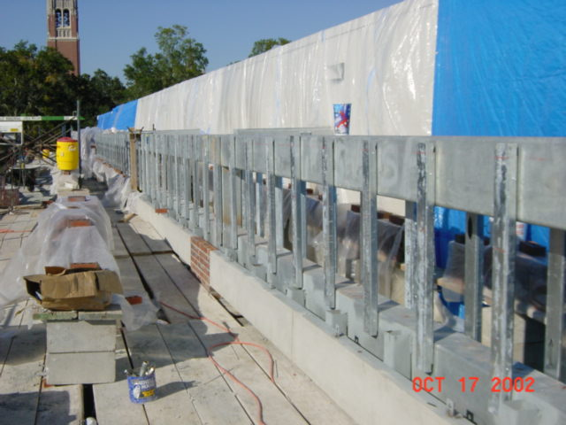
Metal studs in middle
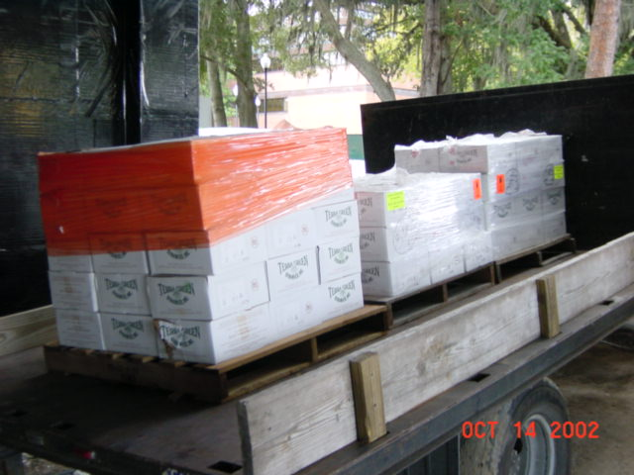
Floor and wall tile
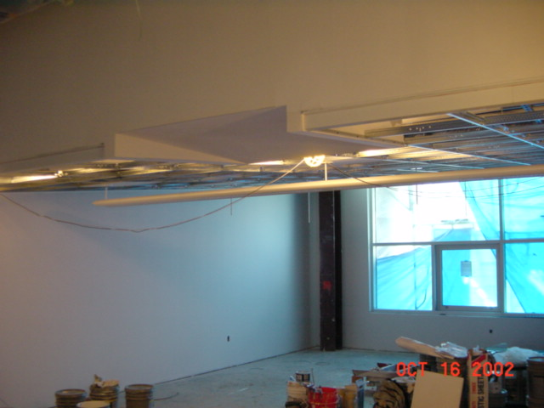
First light fixture
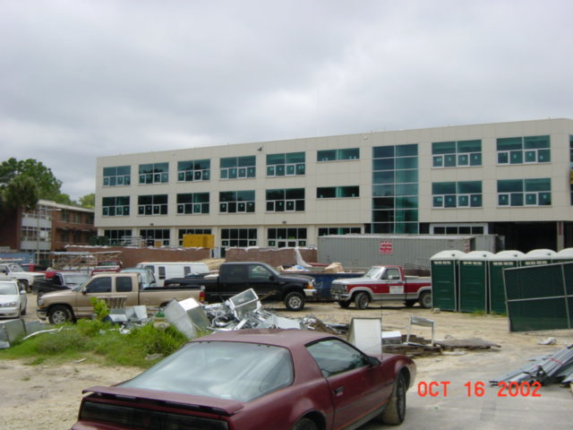
Site from E

