Week of September 23, 2002:
The MEPF milestone of having building air operable was achieved this week. WW Gay continued final rough-in work of the ductwork at the 3rd and 2nd floors. Miller Electric continued pulling wire at the 3rd floor. Miller Electric has begun delivering lighting fixtures to the on-site storage trailer west of the north entry. University of Florida continued pulling data cabling at the 2nd floor. Brown Automatic completed piping work at the 1st floor and all underground work for the fire pump, PIV, etc. was completed. Kone Elevator continued installation of the elevator.
Trinity Fabricators completed installation of the steel atrium opening
rails and stair handrails.
Kistler-McDougall continued installation of the 1st floor metal panels at the east elevation.
(See attached file: Red corner plus brick.JPG)
Lake Glass & Mirror continued installation of the operable windows and also began installation of the atrium glass draftstops.
(See attached file: Img_1360.jpg)
Mac Drywall continued drywall, taping and finishing of 3rd floor walls and ceilings, and also began drywall work at the 1st floor. Metal framing work for the brick facade wall at the west elevation continued.
Allan Spear began installation of the brick at the west facade wall.
Precast work also continued for the facade wall. The Safety Departments at Centex Rooney and Alan Spear continue to work in unison to ensure the scaffold and work practices for the facade wall remain safe for the workers.
(See attached file: Brick from Scaffold.JPG)(See attached file: Brick at NW Pier.JPG)(See attached file: Img_1362.jpg)(See attached file: Img_1358.jpg)
Olympic Painting continued priming and painting work at the 2nd floor.
Suncoast Acoustical began grid work at the 2nd floor.
(See attached file: Start of Grid.JPG)
If you have any questions, please contact me.
Cathy Underhill
Centex Rooney Construction Co., Inc.
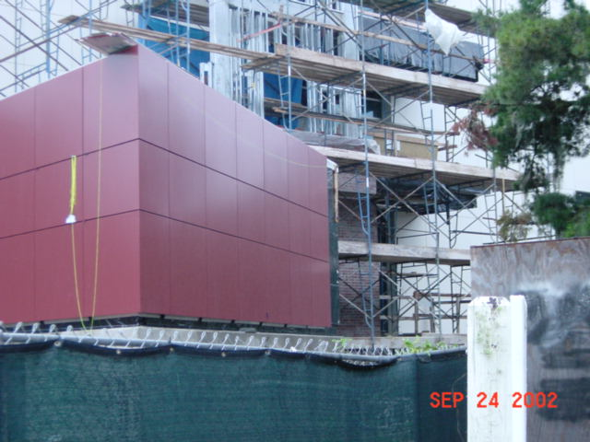
Red corner plus brick
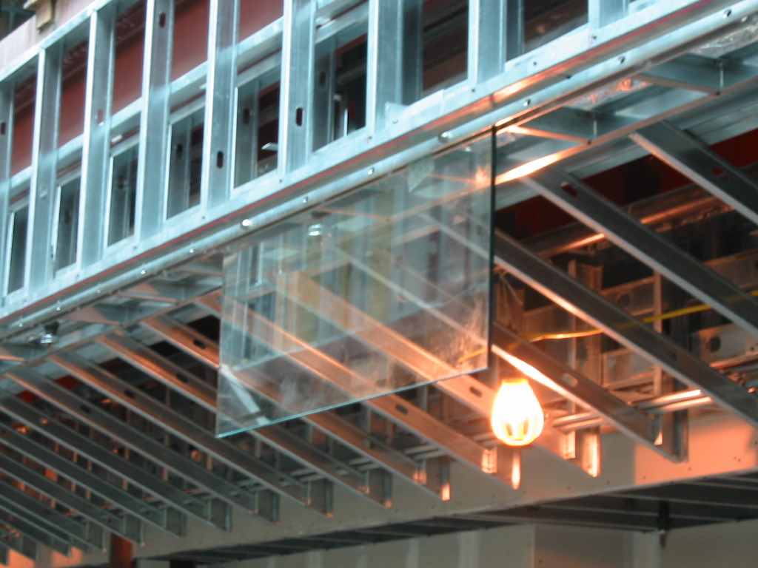
Img_1360
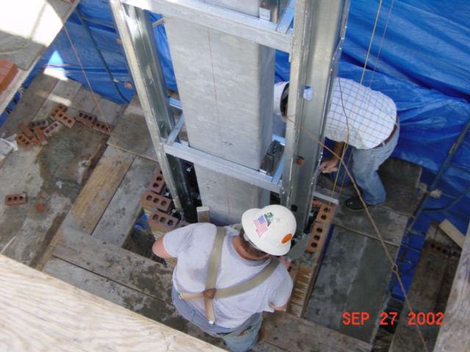
Brick from Scaffold
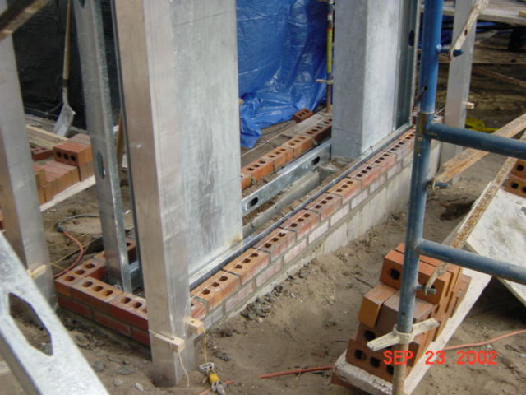
Brick at NW Pier
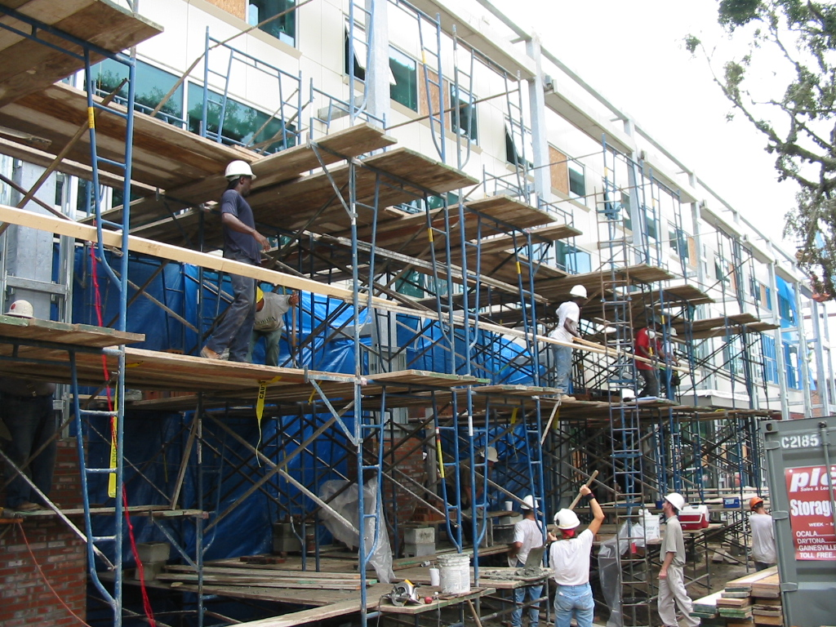
Img_1362
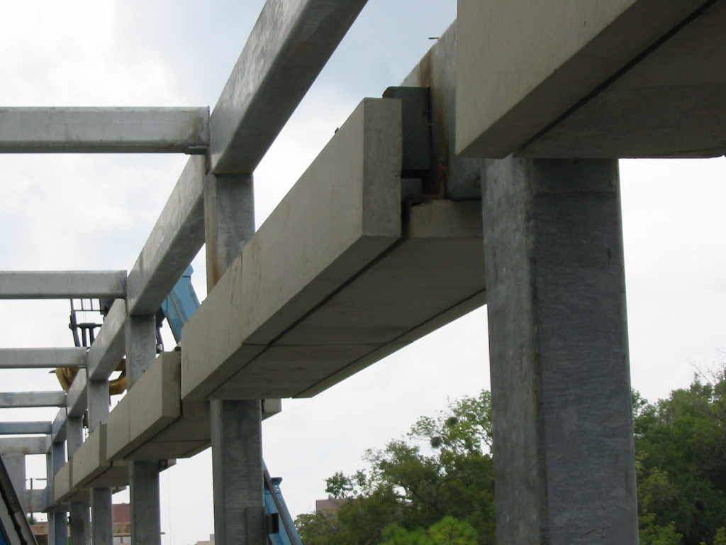
Img_1358
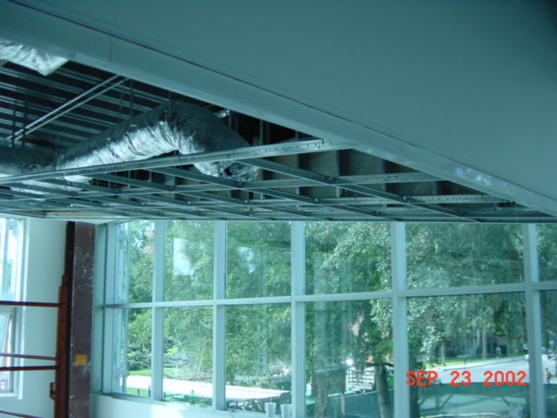
Start of Grid

