Week of April 29, 2002:

Cox Concrete poured the 3rd floor concrete slab after passing inspections
by Universal Engineering (Threshold Inspector) and EH&S.
(See attached file: 3rd Floor Deck.JPG)(See attached file: Rinker at Pump
2.JPG)
Miller Electric, Encompass/Ray's Plumbing and WW Gay continued with
underground work at the slab-on-grade and rough-in at the mechanical room.
This work included rough-in toward the revised layout of the Mechanical
Room/Electrical Room.
(See attached file: Underground Rough-in.JPG)(See attached file: Gray water
pressure lines.JPG)

Trinity Fabricators continued installing the tube steel framing at the 2nd
and 3rd floor perimeters. Tube steel framing at the roof has also begun
including installation of skylight framing.
(See attached file: 3rd Floor Frames.JPG)(See attached file: Tall
Frame.JPG)(See attached file: Skylight subframe.JPG)

Centex Rooney would like to congratulate Ms. Mia Asmus, project co-op from
the M. E. Rinker, Sr. School of Building Construction, for the "Outstanding
Student Service Award" she received at the Rinker school's graduation
ceremony on Friday night, May 3, 2002. Mia has decided to join the Centex
Rooney team as a full-time Project Engineer after graduation and will be
moving to the Ft. Lauderdale area in June. The Rinker Hall project team
wishes her well in her career. She will be missed!

If you have any questions or comments, please contact me.

Cathy Underhill
Centex Rooney Construction Company

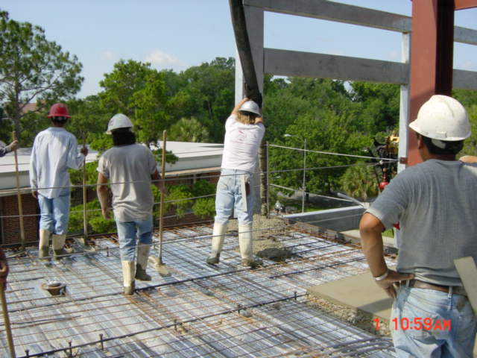
3rd Floor Deck
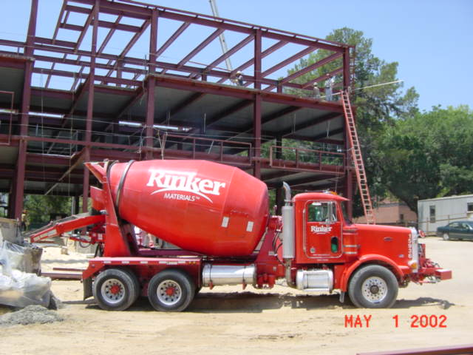
Rinker at Pump 2
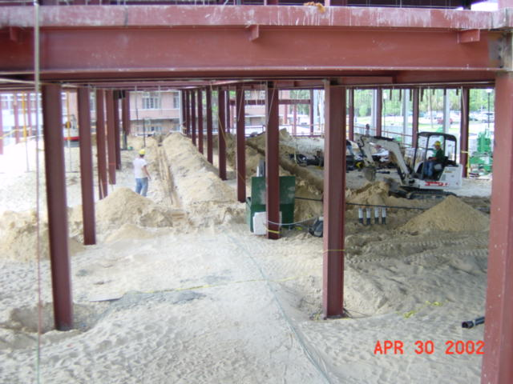
Underground Rough-in
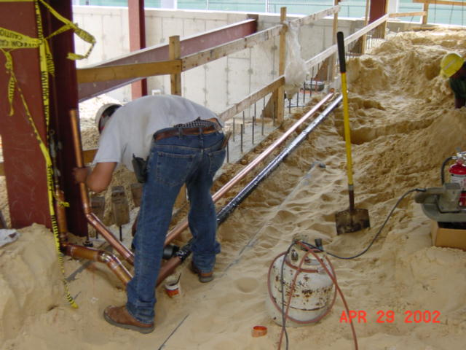
Gray water pressure lines
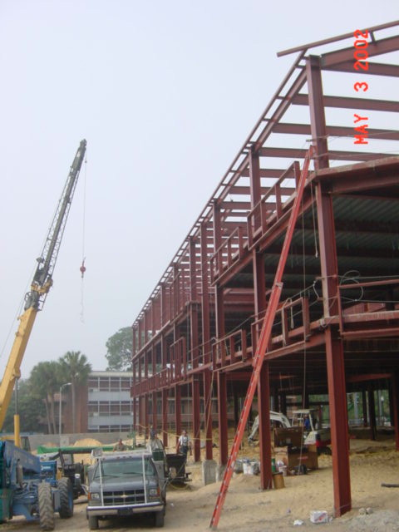
3rd Floor Frames
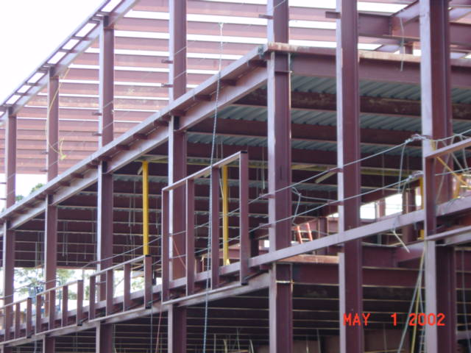
Tall Frame
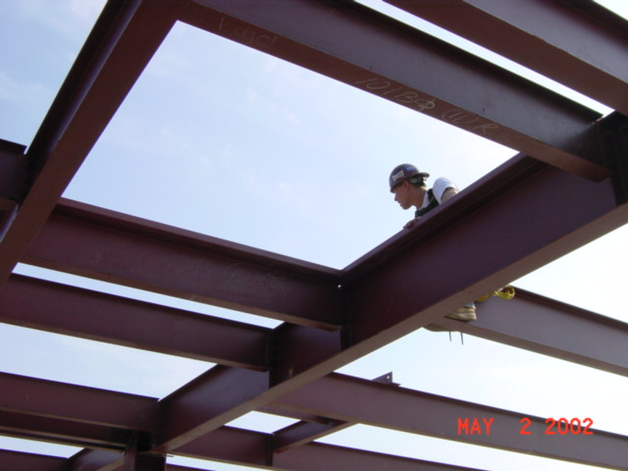
Skylight subframe

