Week of July 15, 2002:

Cox Concrete installed the housekeeping pads at the mechanical room. The
remaining foundation at the construction yard wall was poured.
(See attached file: AHU Housekeeping Pad.JPG)

All Florida Electric pulled cable for the primary electric from the
Substation to the Transformer.

WW Gay installed the Air Handling Units in the Mechanical Room and
continued interior rough-in of Ductwork/VAV Installation and Piping.
Miller Electric, Brown Automatic and Ray's Plumbing also continued with
MEPF rough-in work.
(See attached file: Dcp_1895.jpg)

Mac Drywall continued with interior metal framing. Exterior sheathing was
completed at all elevations except the North elevation. Drywall at the
firerated partitions is being installed.
(See attached file: Dcp_1889.jpg)

Allan Spear began installation of the brick at the construction yard wall,
and continued installing block on the foundation poured this week.
(See attached file: Brick before cleaning.JPG)(See attached file: Brick
cleaning 2.JPG)

If you have any questions or concerns, please contact me.

Cathy Underhill
Centex Rooney Construction Co., Inc.

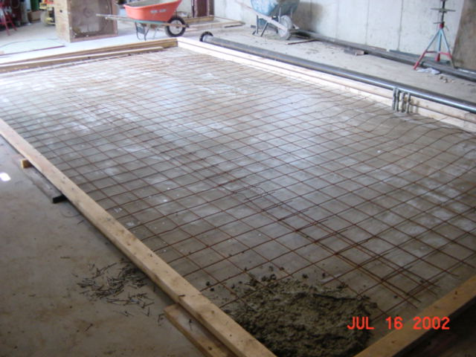
AHU Housekeeping Pad
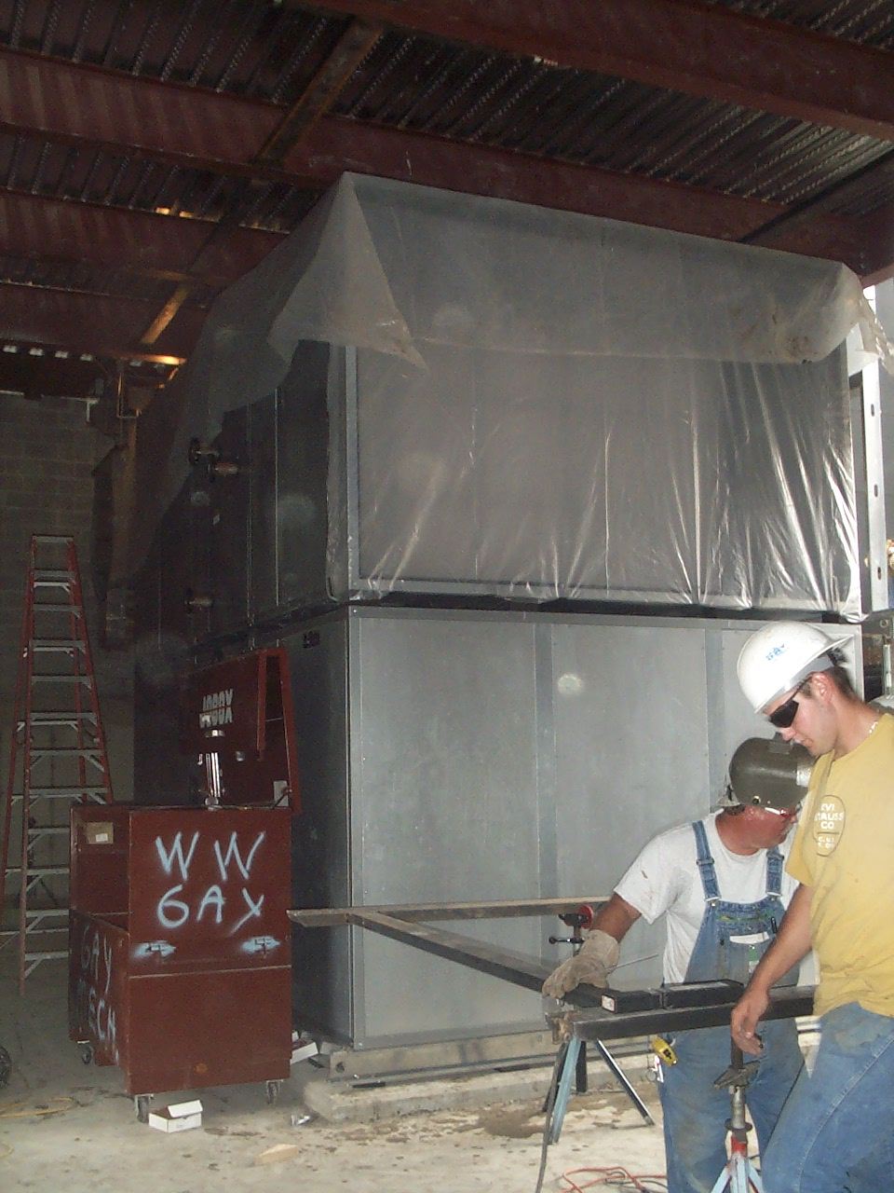
Dcp_1895
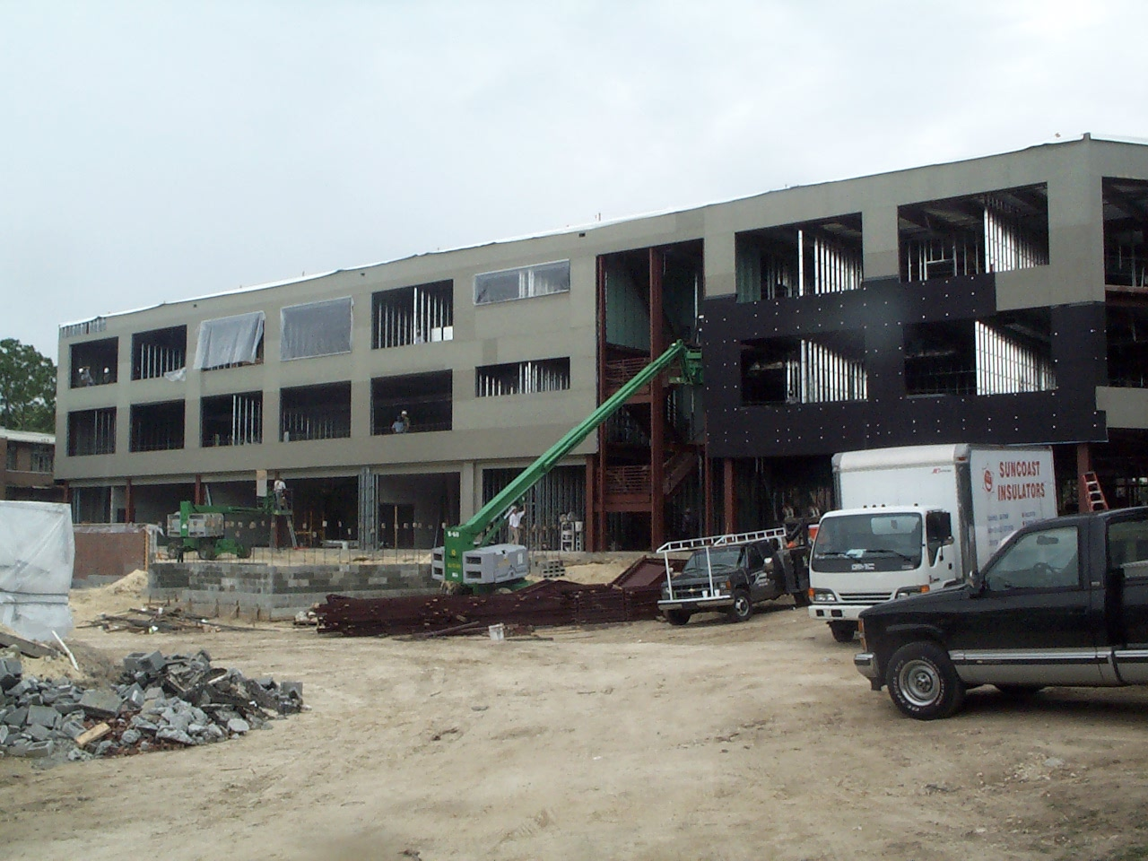
Dcp_1889
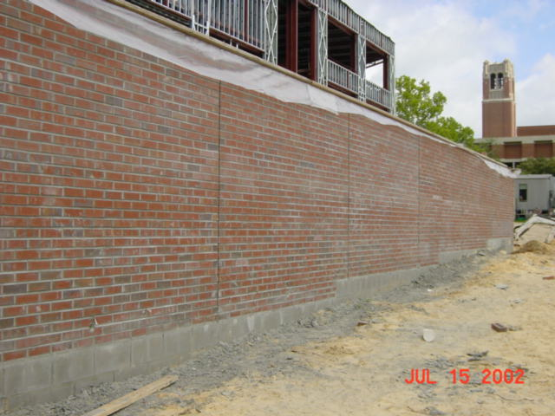
Brick before cleaning
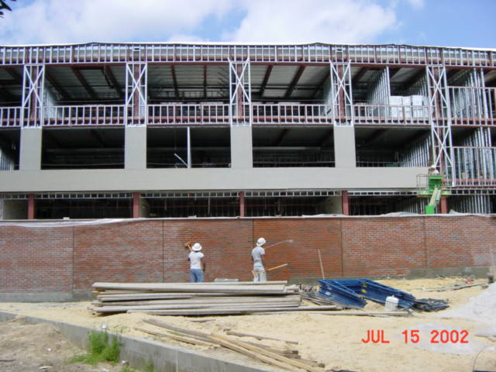
Brick
cleaning 2

