Week of June 10, 2002:

Mac Drywall continued exterior metal framing work and has completed 90% of
the south and west elevations. Interior metal framing work has begun at
the 3rd floor.
(See attached file: Framing at West Elevation.JPG)(See attached file: South
Stair Framing.JPG) (See attached file: South Stair Framing 2.JPG)

MEP rough-in continued on all floors. Encompass/Ray's Plumbing completed
underground at the Mechanical Room.
(See attached file: Plumbing in Mech. Rm.JPG)

Peach State Roofing began installation of the TPO roofing.
(See attached file: Monitor in Action.JPG)(See attached file: Hot Seam.MPG)

Trinity Fabricators installed the stairs and handrails adjacent to the
elevator and is now finishing up associated welding work.
(See attached file: Start of Stairs.JPG)

All Florida Electric continued with the primary electrical ductbank behind
the Music Building and is continuing onto the Stadium Road crossing work.
(See attached file: Core drilling, Stadium manhole.JPG)

Coastal Mechanical completed the steam and condensate tie-in at the
building.
(See attached file: Steam Expansion Loop.JPG)(See attached file: Steam into
building.JPG)

If you have any questions or comments, please contact me.

Cathy Underhill
Centex Rooney Construction Co., Inc.

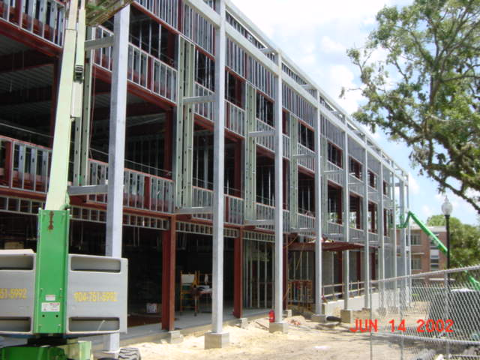
West Elevation
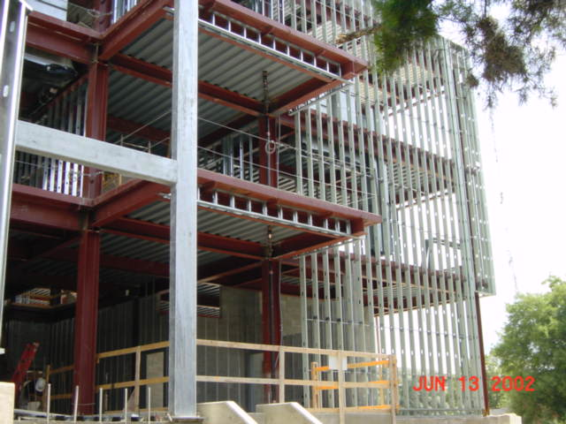
South
Stair Framing
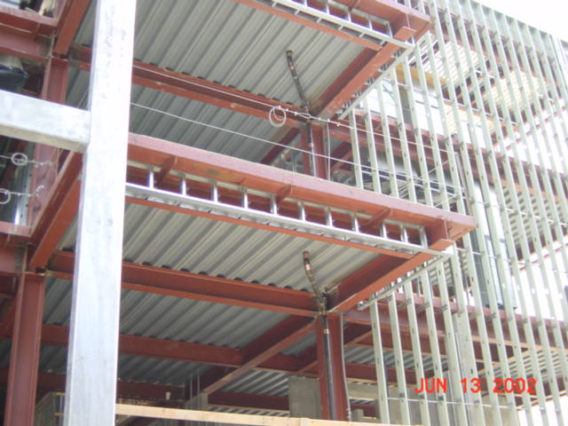
South Stair Framing 2
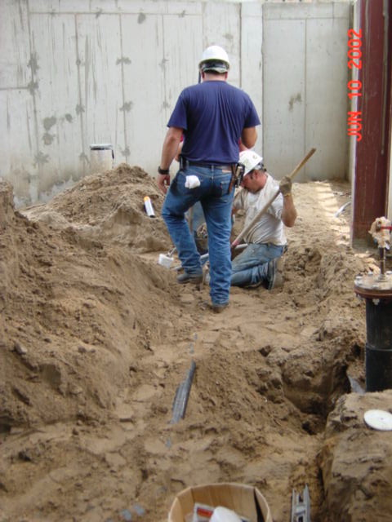
Plumbing in Mech. Rm
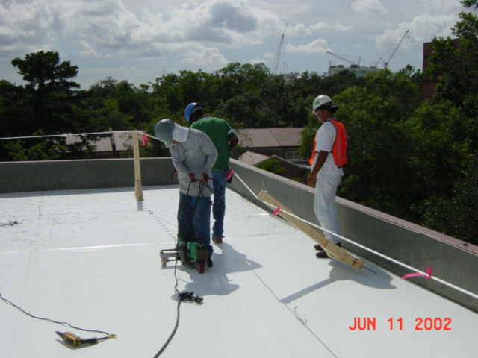
Monitor in Action
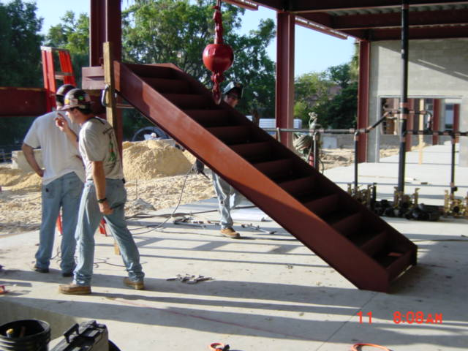
Start of Stairs
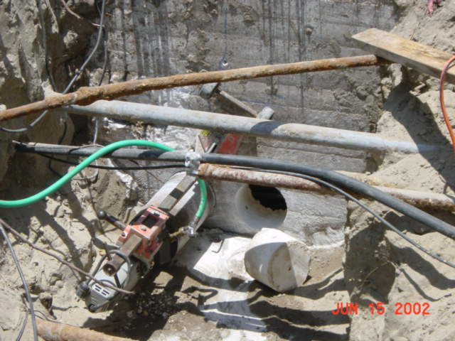
Core drilling, Stadium manhole
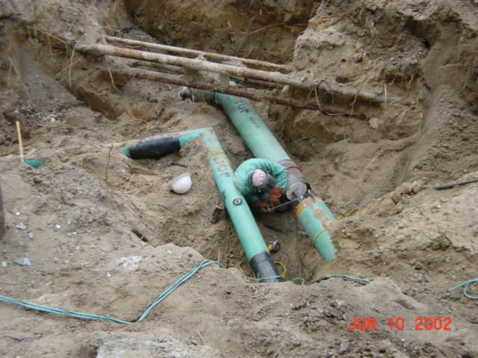
Steam Expansion Loop
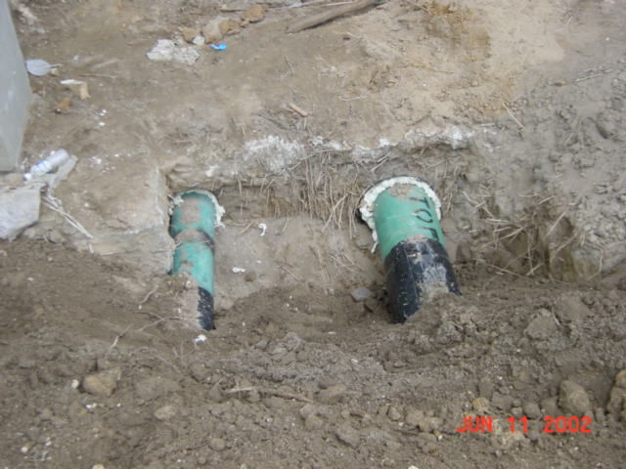
Steam into
building

