Week of June 24, 2002:

Mac Drywall continued with exterior framing at the east facade as well as
exterior sheathing installation. The majority of the west facade and a
portion of the south facade exterior sheathing is completed. Interior
metal stud framing began at the first floor.
(See attached file: Gyp. Board at South Stair.JPG)(See attached file: NE
corner framing.JPG)(See attached file: East Framing.JPG)

Cox Concrete completed the concrete pour at the mechanical room
slab-on-grade and central stairs adjacent to the elevator.
(See attached file: Waterstop at Mech. Room.JPG)(See attached file: Rinker
at Mech. room pour.JPG)(See attached file: Joints at Mech. Room.JPG)(See
attached file: Screeding Strair with Jig.JPG)

All Florida Electric completed all primary ductbank work and began
installation of the switch pit.
(See attached file: Final duct bank pour.JPG)(See attached file: Switch Pit
opening.JPG)

MEP rough-in work continued by Miller Electric, WW Gay and Encompass/Ray's
Plumbing. Equipment began arriving on site - fans, VAV boxes and
switchgear.

(See attached file: Main Switchgear.JPG)(See attached file: Smoke Fans.JPG)
(See attached file: VAVs.JPG)

Peach State Roofing began installed the roof membrane at the mechanical
room.

Brown Automatic began installing sprinkler piping at the second floor.
They tested the fire lines to complete hydraulics for the fire protection
system on 6/26/02. Signed and sealed drawings were received on Friday and
delivered to EH&S.
(See attached file: Hydrant Test.JPG)

If you have any questions or comments, please contact me.

Cathy Underhill
Centex Rooney Construction Co., Inc.

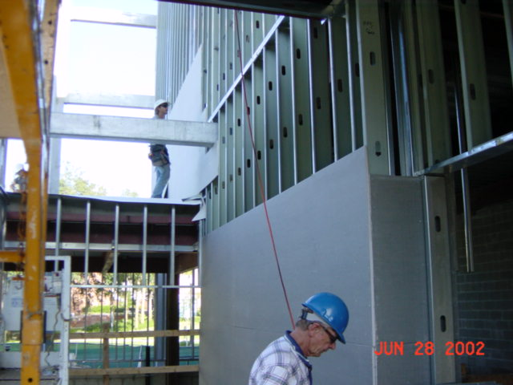
Gyp. Board at South Stair
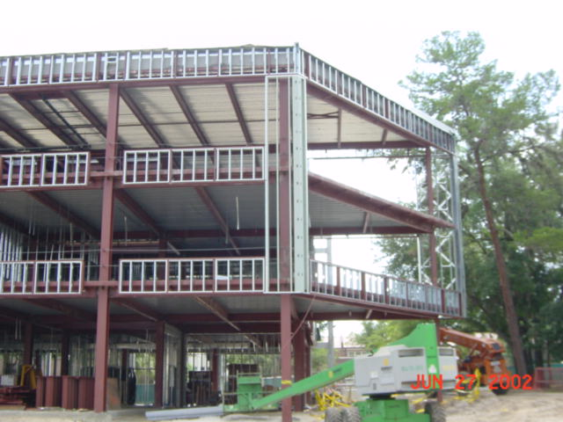
NE
corner framing
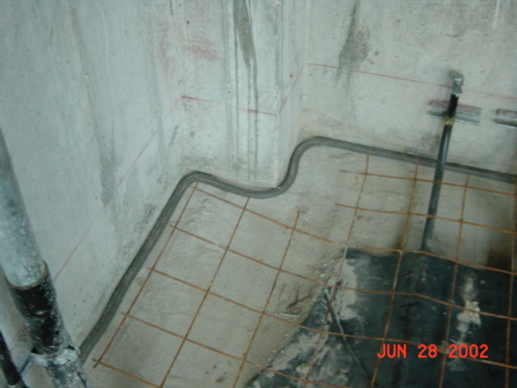
Waterstop at Mech. Room
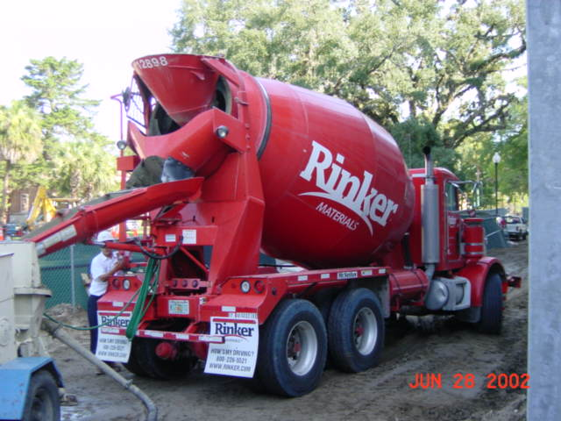
Rinker
at Mech. room pour
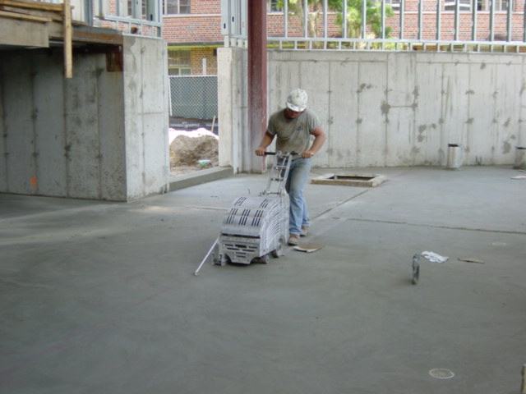
Joints at Mech. Room
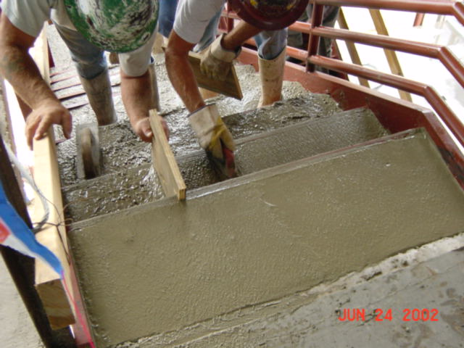
Screeding Strair with Jig
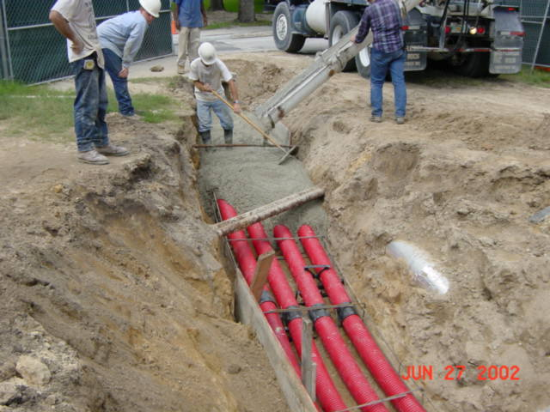
Final duct bank pour
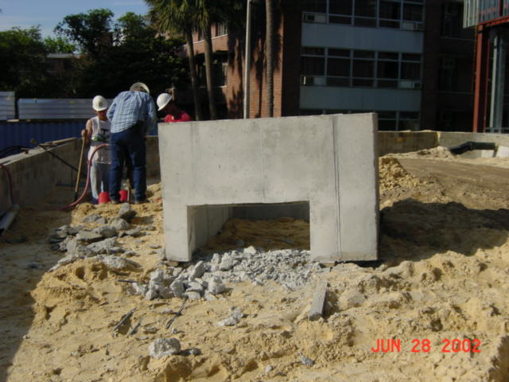
Switch Pit
opening
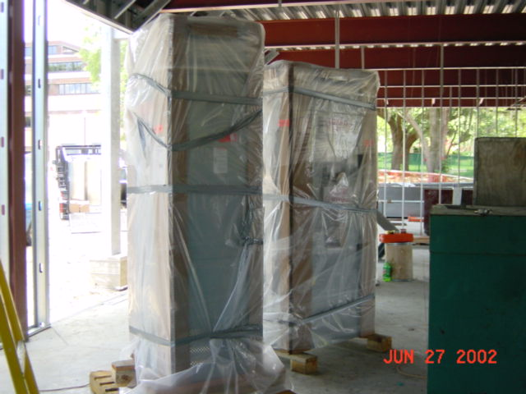
Main Switchgear
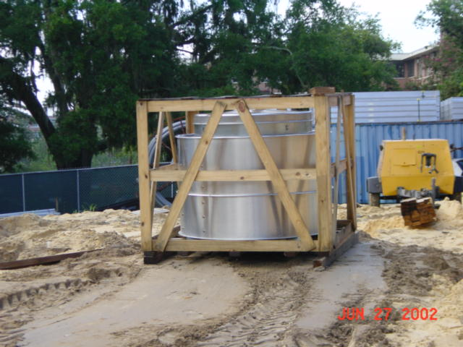
Smoke Fans
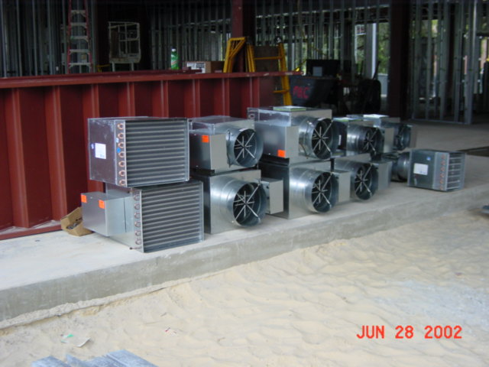
VAVs
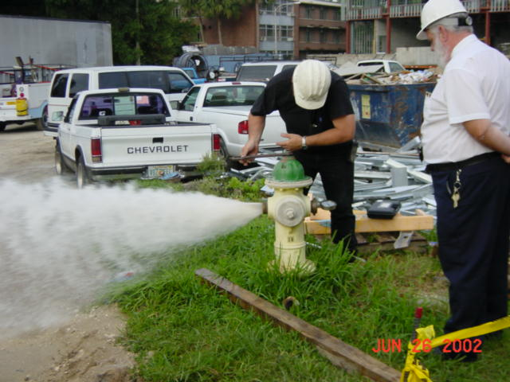
Hydrant Test

