---------------------- Forwarded by Cathy Underhill/Rooney/CCG on
06/14/2002 01:48 PM ---------------------------

Cathy Underhill
06/07/2002 06:45 PM

To: bbrown@ufl.edu, ckibert@ufl.edu, jtmcc@admin.ufl.edu, jrae@geaf.com,
jseitz@croxtonarc.com, mrios@ufl.edu, cjw@ufl.edu, cge@admin.ufl.edu,
kmikkelsen@lehrassoc.com
cc: bcollie@ccgmail.com, bwilson@ccgmail.com, vfrederick@ccgmail.com,
mmiller@ccgmail.com, Mike Wood/Rooney/CCG@CENTEX, Mia
Asmus/Rooney/CCG@CENTEX, Bryan Parker/Rooney/CCG@CENTEX, Andrea
Whilby/Rooney/CCG@Centex

Subject: Rinker Hall Update - Week of June 3, 2002

Week of June 3, 2002:

Mac Drywall II continued with metal stud work at the building exterior.
They completed stud work of the tube steel frames at the perimeter of the
3rd floor and began work at the 2nd floor. They also began interior metal
stud work at the 3rd floor after the lightweight deck was poured.
Firesafing for perimeter slabs was delivered.
(See attached file: Third floor framing.JPG)(See attached file: Fire
safing.JPG)

Elastizell completed the tapered insulation and lightweight concrete work
at the main roof and mechanical roof.
(See attached file: Lightweight 1.JPG)(See attached file: Lightweight
2.JPG)

Peach State Roofing delivered TPO roofing materials to the roof in
preparation for roofing work to begin next week.
(See attached file: TPO Roof.JPG)

Miller Electric completed the electrical ductbank and backfill work at the
construction yard. An additional conduit was installed in anticipation of
the fire pump.
(See attached file: Primary feed.JPG)(See attached file: Completed duct
bank.JPG)

WW Gay continued with rough-in and ductwork installation.
(See attached file: 2nd Floor Duct.JPG)(See attached file: Temp. Cover on
end of duct.JPG)

Encompass/Ray's Plumbing completed rainwater leader work and the rainwater
collection tank is now filling up.
(See attached file: Rainwater leader final.JPG)

Allan Spear completed the interior masonry walls and has demobilized.
(See attached file: CMU Wall Brace.JPG)

Coastal Mechanical continued work on the steam and condensate lines.
(See attached file: Condensate Line.JPG)

Brown Automatic installed the fire line feed into the mechanical room.
(See attached file: Fire line sleeve.JPG)

Cox Concrete formed and poured the south stair stringers and continued
forming and pouring the concrete bases at the galvanized tube steel
columns.

If you have any questions or comments, please contact me.

Cathy Underhill
Centex Rooney Construction Company

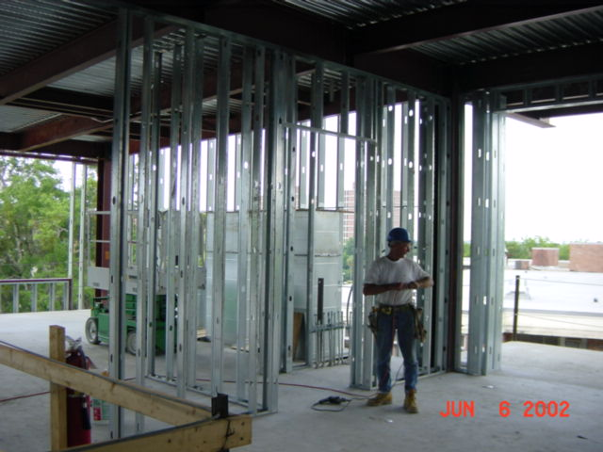
Third floor framing
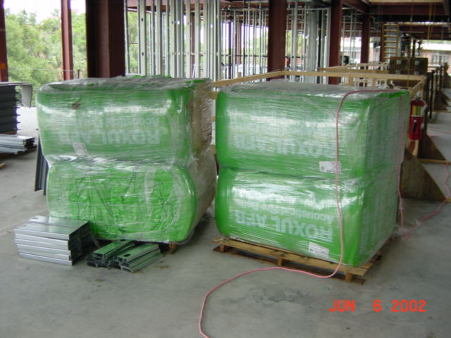
Fire
safing
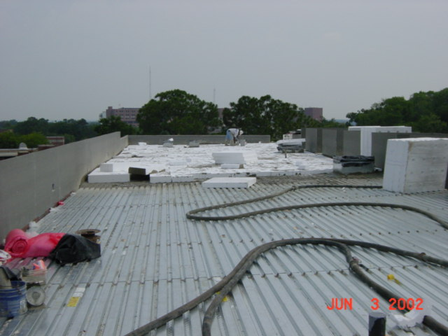
Lightweight 1
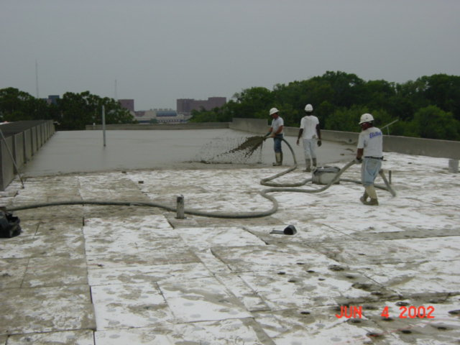
Lightweight
2
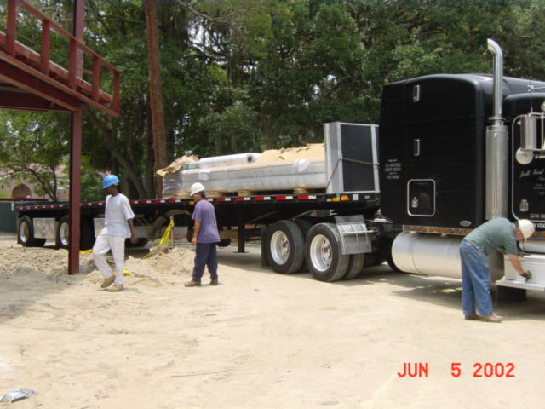
TPO Roof
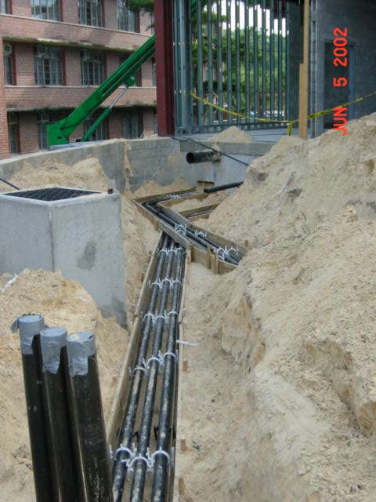
Primary feed
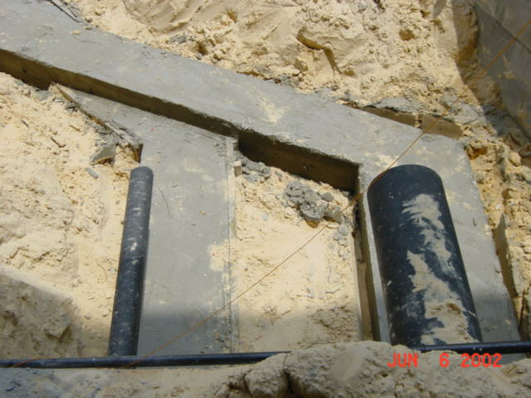
Completed duct
bank
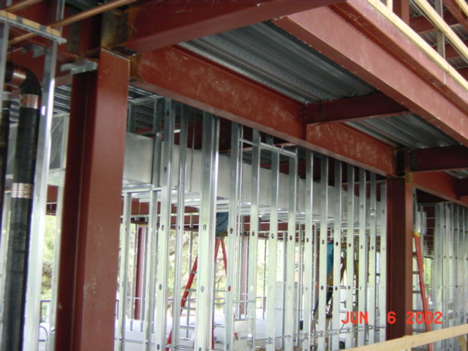
2nd Floor Duct
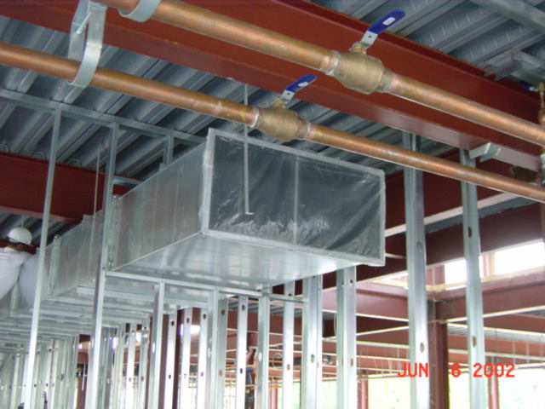
Temp. Cover on
end of duct
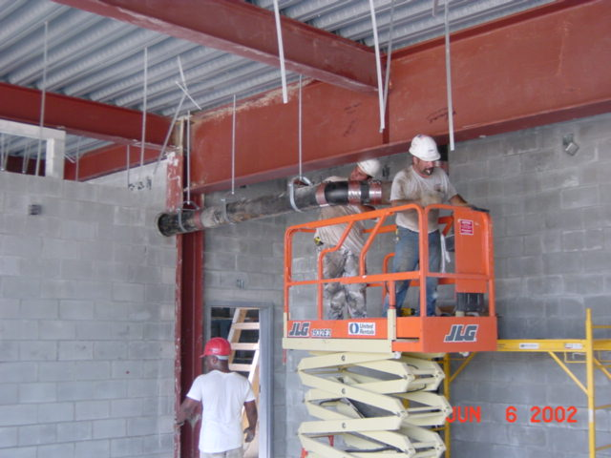
Rainwater leader final
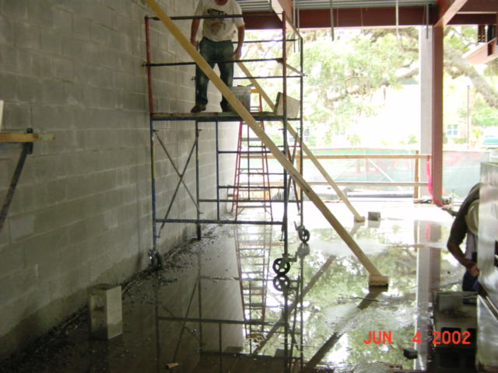
CMU Wall Brace
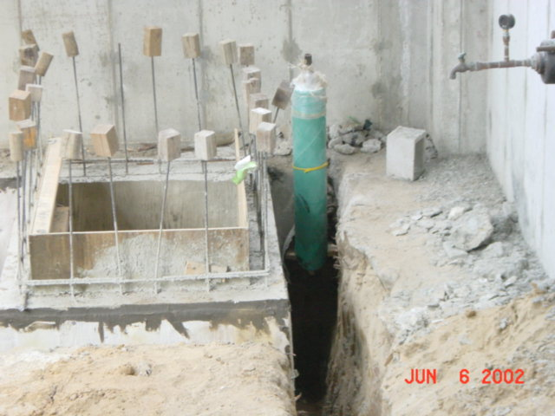
Condensate Line
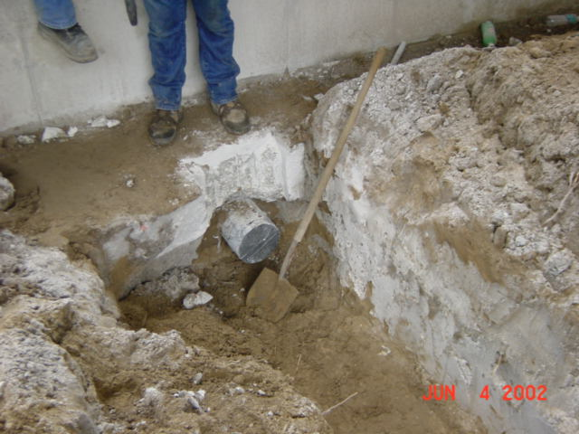
Fire line sleeve

