Week of May 27, 2002:

Mac Drywall continued exterior metal stud work completing the work around
the mechanical room and roof parapet. Exterior sheathing was completed at
the skylight curbs and roof parapet in preparation for the lightweight
concrete at the roof deck.
(See attached file: Blocking at skylights.JPG)(See attached file: Start of
Ext. Gyp. Sheathing.JPG)
Allan Spear continued masonry block wall work on the first floor.
(See attached file: CMU at Structures Lab.JPG)(See attached file: CMU at
MEPF Studio.JPG)
Miller Electric, WW Gay and Ray's Plumbing continued with building rough-in
for MEP work.
(See attached file: Waste and Vent 1st fl restroom.JPG)
Cox Concrete poured the bases at the galvanized steel tubes for the brick
facade wall.
(See attached file: Brick Bases.JPG)

Watson Construction began backfill work at the construction yard.
(See attached file: Backfill at const. yard.JPG)

UF completed asbestos removal and new insulation work at the existing steam
line north of the building. This work is being handled through PPD and is
outside CRCC's contract.
(See attached file: New insulation by UF.JPG)(See attached file: Asbestos
removal by UF.JPG)

If you have any questions or comments, please contact me.

Cathy Underhill
Centex Rooney Construction Company

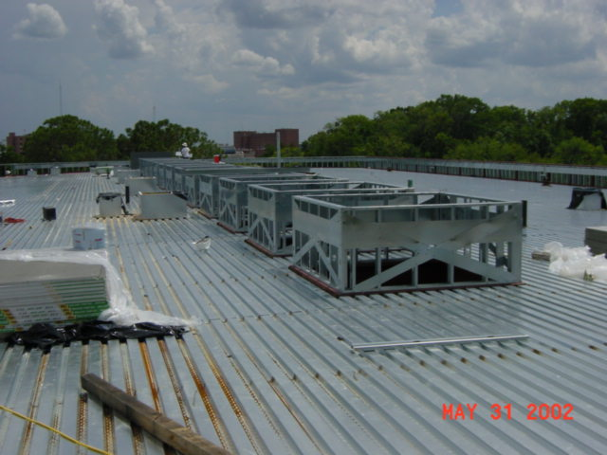
Blocking at skylights
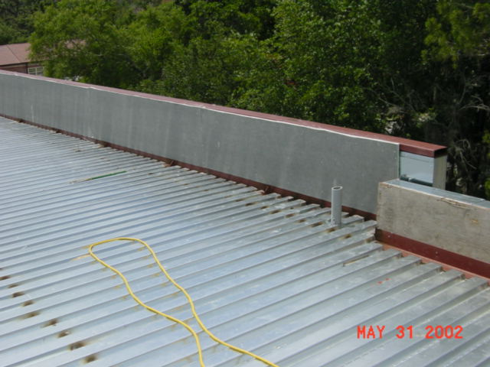
Start of
Ext. Gyp. Sheathing
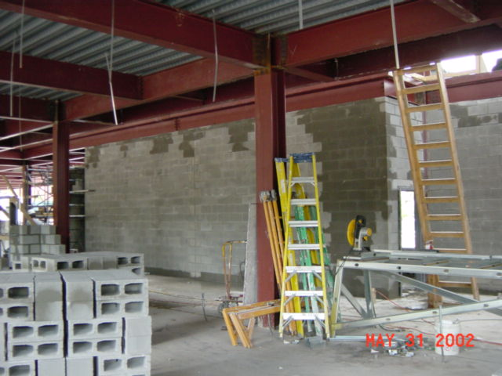
CMU at Structures Lab
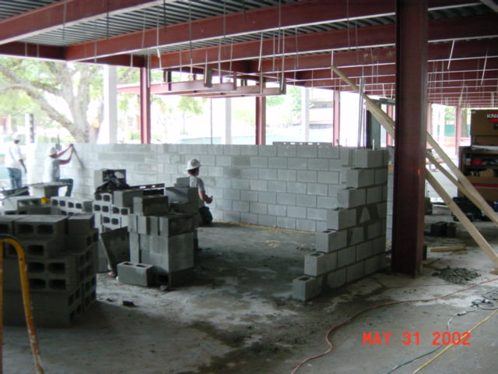
CMU at
MEPF Studio
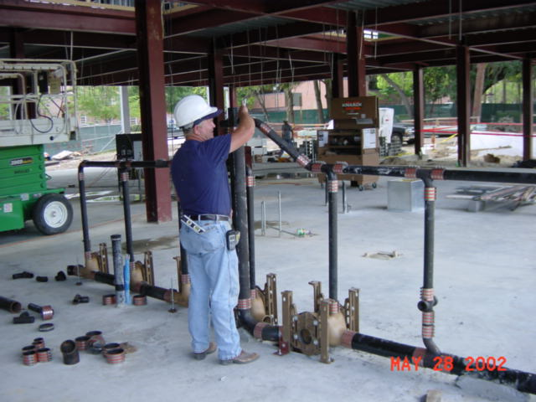
Waste and Vent 1st fl restroom
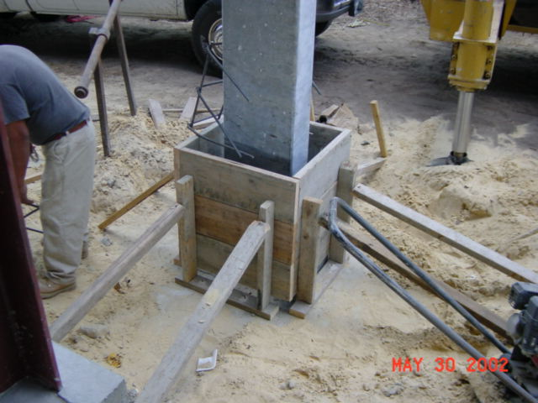
Brick Bases
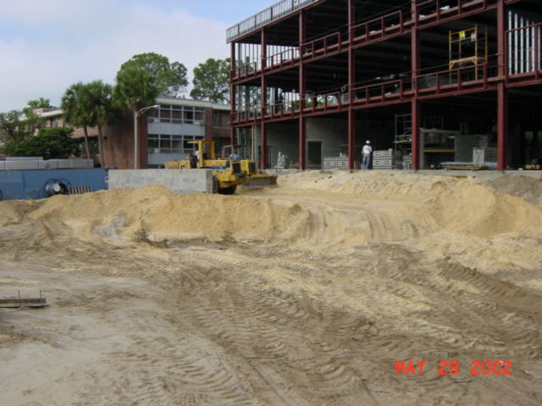
Backfill at const. yard
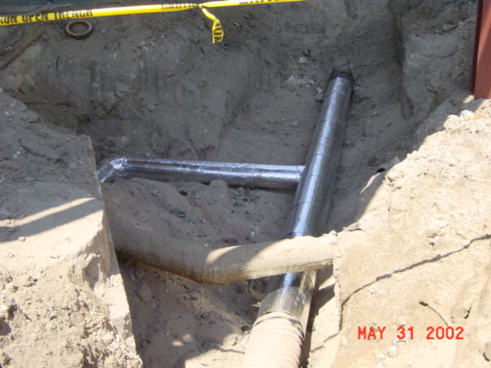
New insulation by UF
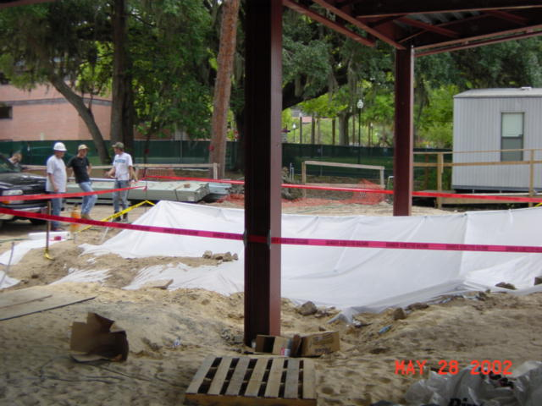
Asbestos
removal by UF

