Week of May 6, 2002:

Cox Concrete prepared to pour slab-on-grade for the main 1st floor area
including below grade radon protection work (Enkavent). Two separate
concrete pours will be made.
(See attached file: Slab Prep.JPG)(See attached file: Radon Vent Pit.JPG)
(See attached file: Radon Vent.JPG)(See attached file: Grading at Mech.
Room.JPG)

MEP underground work continued for slab-on-grade. EH&S inspected the work
accordingly.
(See attached file: Electrical Rough IN.JPG)

Elastizell installed the ventilated roof deck for lightweight concrete.
(See attached file: Roof Deck in Place.JPG)

Coastal Mechanical began the Newell Road crossing work for the new steam
lines. Many existing utilities were encountered at differing elevations
prohibiting us for progressing with the work. PPD was not available to
review/approve the desired path of travel/relocation of utilities. These
decisions will be discussed/approved this week (week of May 13, 2002) so
that work can be continued. The road crossing, therefore, will remain
steel-plated until completion of the work.
(See attached file: Flagging Operation.JPG) (See attached file: Steam Pipe
at Newell.JPG)

(See attached file: Demo Saw.MPG)

Trinity Fabricators completed installation of the 3rd Floor tube steel
framing.
(See attached file: Tube Steel.JPG)

Grading/fill of the Mechanical Room was completed.
(See attached file: Grading at Mech. Room.JPG)(See attached file: Grading
at Mech Room.JPG)

If you have any questions or concerns, please contact me.

Cathy Underhill
Centex Rooney Construction Company

---------------------------------------------------------------------

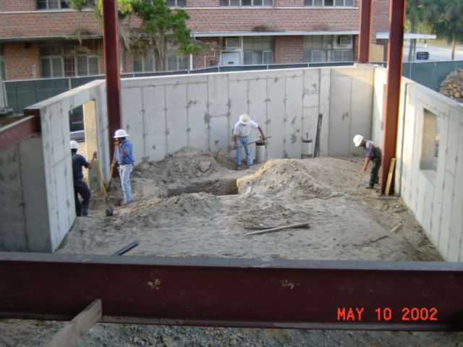
Grading at Mech Room
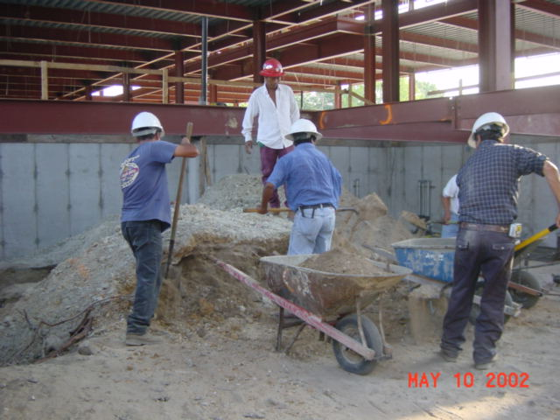
Grading at Mech Room
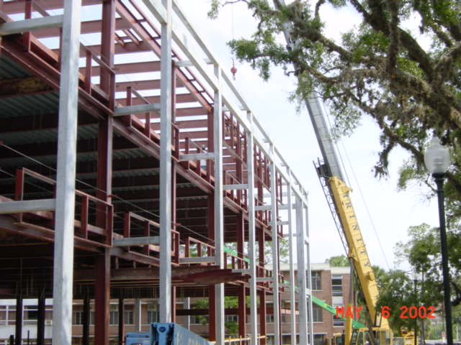
Tube Steel
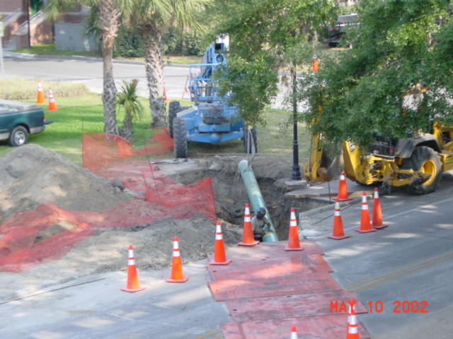
Steam Pipe at Newell
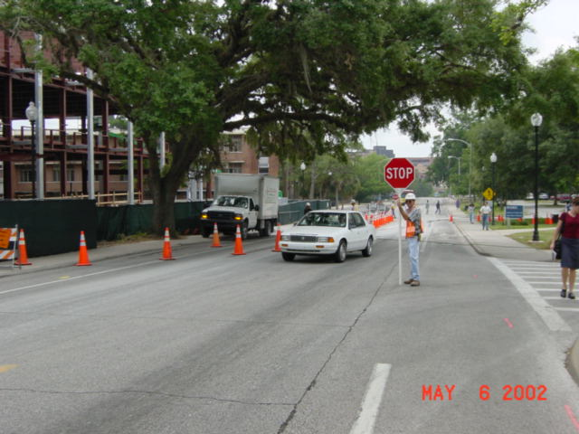
Flagging Operation
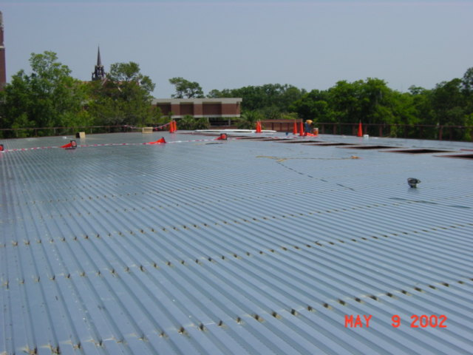
Roof Deck in Place
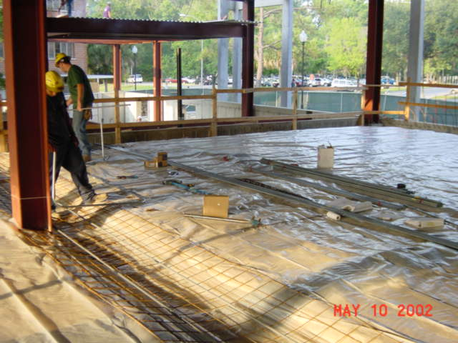
Electrical Rough IN
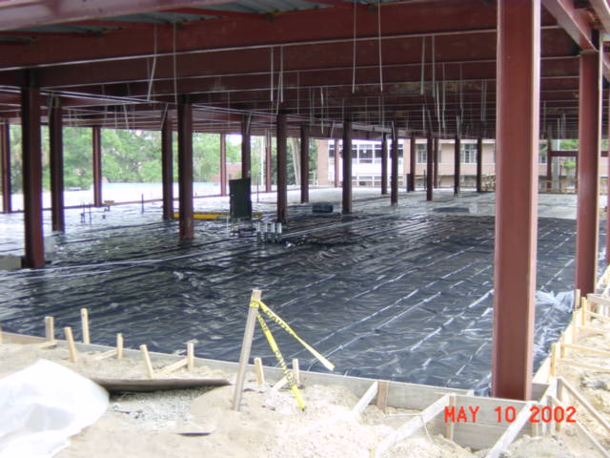
Slab Prep
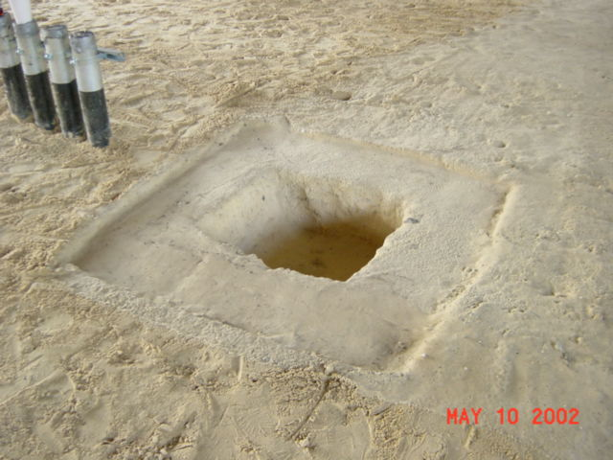
Radon Vent Pit
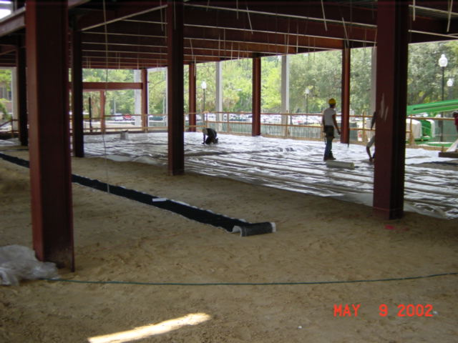
Radon Vent

