Week of September 2, 2002:

Kistler McDougall continued with installation of the oyster metal wall
panel system. Nearly all of the east elevation is complete at the 2nd and
3rd floors.
(See attached file: East Facade.JPG)(See attached file: West Facade.JPG)

Lake Glass & Mirror continued with installation of the curtainwall and
storefront framing and glass.
(See attached file: NE window wall.JPG)(See attached file: NW window
wall.JPG)

Mac Drywall continued with installation of the drywall, insulation and
taping and finishing work at the 2nd and 3rd floors.
(See attached file: Skylight head picture 1.JPG)(See attached file:
Skylight insulation, fiberglass.JPG)

MEPF rough-in work continued by WW Gay, Miller Electric and Brown
Automatic. Temp perm power was energized on Friday afternoon.
(See attached file: High voltage feeds.JPG)(See attached file: High Voltage
Fuse.JPG)(See attached file: Lockout on main breaker.JPG)

Cox Concrete poured the retaining wall north of the construction yard.

Coastal Mechanical completed the final steam cleaning work.
(See attached file: Conductivity Test, reading about 56.JPG)(See attached
file: Start of Steam Flush.JPG)

If you have any questions or comments, please contact me.

Cathy Underhill
Centex Rooney Construction Co., Inc.
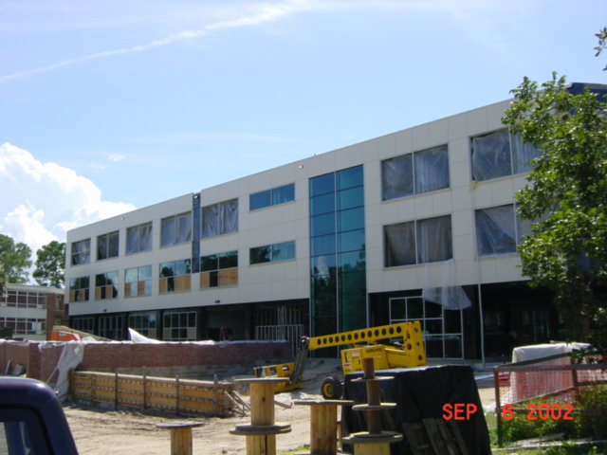
East Facade
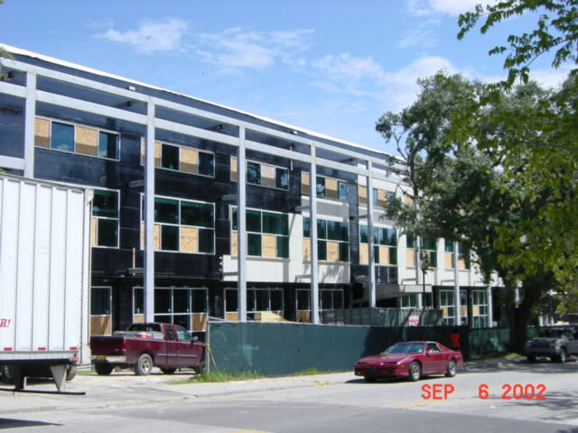
West Facade
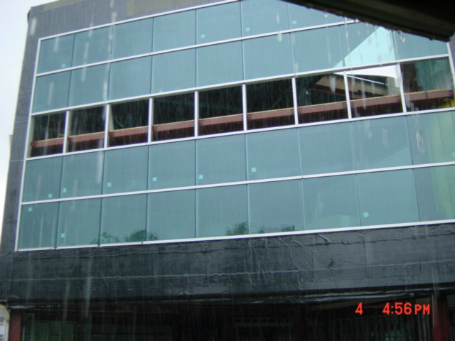
NE window wall
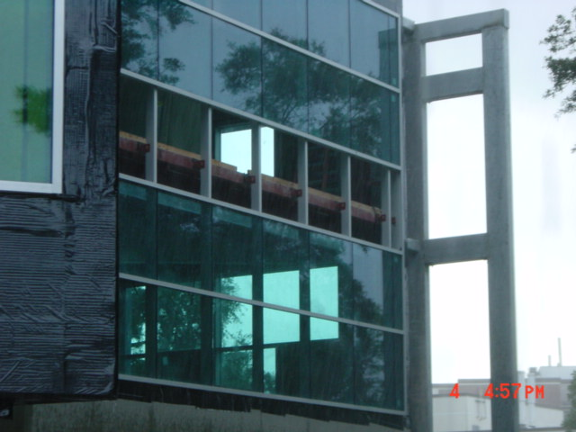
NW window
wall
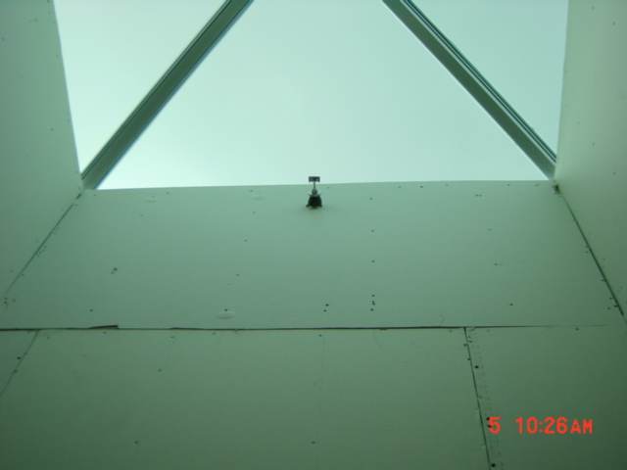
Skylight head picture 1
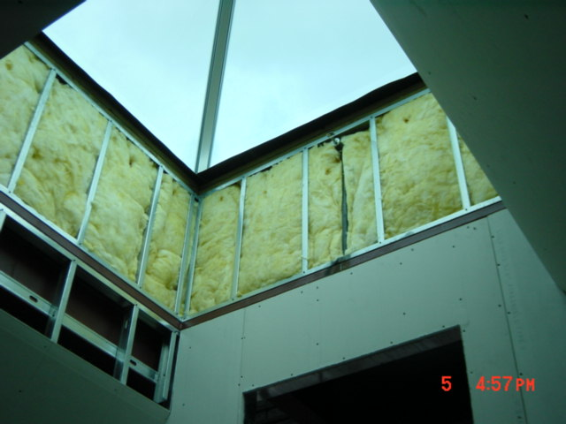
Skylight insulation, fiberglass
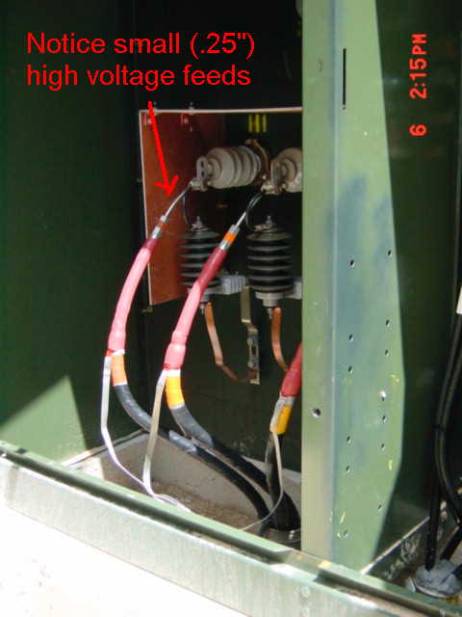
High voltage feeds
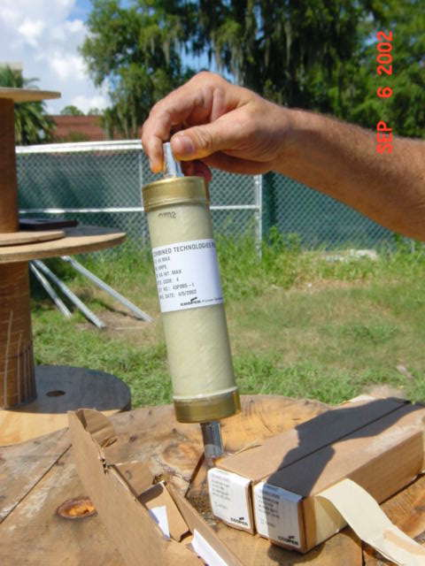
High Voltage
Fuse.
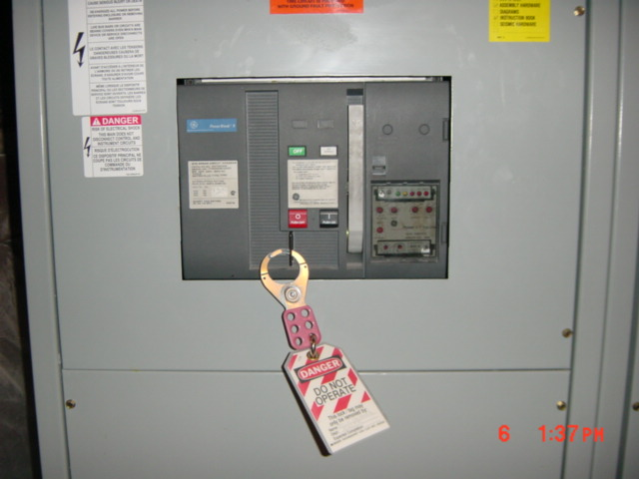
Lockout on main breaker
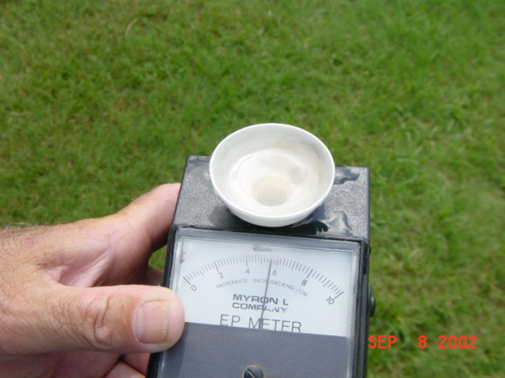
Conductivity Test, reading about 56
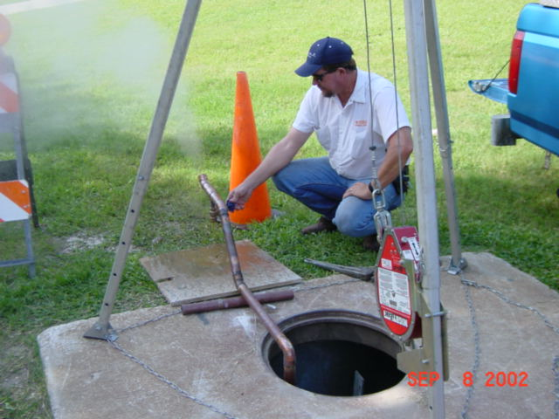
Start of Steam Flush

